CANNON FIRE SUPPORT SPECIALIST

MOS 13F SKILL LEVEL 1

DETERMINE TARGET LOCATIONS AND DIRECTIONS

SUBCOURSE FA 4201-A
October, 2004

US Army Field Artillery School
Fort Sill, Oklahoma

Four Credit Hours

GENERAL

This subcourse is designed to train the skills necessary for performing tasks related to determining target locations and directions. This subcourse is presented in four lessons, each lesson corresponding to a terminal objective supporting the following soldier' s manual tasks:

LESSON 1: Determine Direction Within the Target Area

TASK NO: 061-283-1001

TASK: Determine direction within the target area.

CONDITIONS: You will be given a declinated M2 compass, binoculars, a map of the target area, an observed fire (OF) fan, grease pencils, acetate, and known points.

STANDARDS: Determine the direction to selected points within the target area within 1 minute to an accuracy of ± 100 mils.

LESSON 2: Locate a Target by Grid Coordinates

TASK NO: 061-283-1002

TASK: Locate a target by grid coordinates.

CONDITIONS: You will be given map of the target area, binoculars, an observed fire (OF) fan, a declinated M2 compass, a coordinate scale, and a target.

STANDARDS: Determine and announce the six-digit grid coordinates of the identified target
LESSON 3: Locate a Target by Polar Plot

TASK NO: 061-283-1003

TASK: Locate a target by polar plot.

CONDITIONS: You will be given a map of the target area, binoculars, an observed fire (OF) fan, a declinated M2 compass, a target, and a laser range finder (if equipped).

STANDARDS: Locate the target within 250 meters of the actual location. Announce the target location within 30 seconds after identification. Express direction to the nearest 10 mils and within
100 mils of the actual direction. Express distance to the nearest 100 meters.

LESSON 4: Locate a Target by Shift From a Known Point

TASK NO: 061-283-1004

TASK: Locate a target by shift from a known point.

CONDITIONS: You will be given a map of the target area, binoculars, and a declinated M2 compass. You have identified as a suspected target near a point known by you, to include direction, and the known point is plotted in the fire direction center (FDC). Your own location is plotted on your map.

STANDARDS: Locate the target within 250 meters of the actual location and announce the target location within 30 seconds after identification. Express direction to the nearest 10 mils and within 100 mils of the actual direction. Express right or left corrections to the nearest 10 meters and range corrections to the nearest 100 meters.

TABLE OF CONTENTS

TABLE OF CONTENTS

ADMINISTRATIVE INSTRUCTIONS

Lesson 1: Determine Direction Within the Target Area

Introduction

M2 Compass

Cardinal Direction

Measuring Angular Deviation

Right Add--Left Subtract

Scaling From a Map

Using Other Measuring Devices

Summary

Lesson 2: Locate a Target by Grid Coordinates

Introduction

Estimating Coordinates

Estimating Coordinates Without Overprinted 100-Meter Squares

Measuring Grid Coordinates

Terrain Features

Terrain Association

Observer Aids

Summary

Lesson 3: Locate a Target by Polar Plot

Introduction

Description

Determining Direction

Determining Distance

Vertical Shift

Summary

Lesson 4: Locate a Target by Shift From a Known Point

Introduction

Description

Known Point

Direction to the Target

Angular Deviation

Measure Angular Deviation

Determine Direction Using Angular Deviation

Measuring Angular Deviation and Direction With Binoculars

Lateral Shift

Mil Relation Formula

Range Shift

Vertical Shift

Summary

EXAMINATION

ADMINISTRATIVE INSTRUCTIONS

Subcourse content. This subcourse contains four lessons, each related to determining target locations and directions. An introduction presents an overall view of the subject. Each lesson then explains how to perform each task as it pertains to the field artillery forward observer.

Supplementary requirements. The following subcourses should be completed before taking this subcourse:

a. FA 4022, Map Reading I.

b. FA 4023, Map Reading II.

Prerequisites are based upon skill progression solely within the correspondence course curricula. Therefore, enrollees who have acquired this included knowledge from other sources may not need to complete listed subcourse(s). If unable to complete this subcourse because of lack of prerequisite knowledge, request the prerequisite subcourse(s) from:

Materials needed. You will need:

a. ZARKI map (Part of adjunctive material).

b. Plastic observed fire fan (Part of adjunctive material).

c. Plastic coordinate scale (Part of adjunctive material).

Lesson 1

DETERMINE DIRECTION WITHIN THE TARGET AREA

OBJECTIVE

After completing this lesson, you will be able to determine direction by use of one of the following methods: using a compass, measuring from a reference point, estimating, scaling from a map, or using other measuring devices.

REFERENCES

This lesson is based on FM 6-30 and other materials approved for US Army field artillery instruction; however, development and progress render the text continually subject to change. Therefore, base your examination answers on material presented in this lesson rather than on individual or unit experience.

1. INTRODUCTION. The primary function of personnel assigned to the fire support team (FIST) is to serve as forward observer (FO) for maneuver elements. The FO serves as the eyes of all indirect fire systems, locating suitable targets within his zone of observation.

2. M2 COMPASS. The M2 compass (Figure 1) is one of the primary instruments used by artillery FOs to determine direction within the target area.
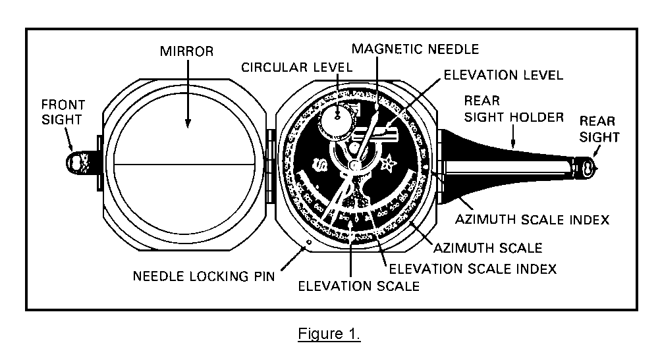
a. The M2 compass has two scales: azimuth (direction) and elevation. Only the azimuth scale will be discussed in this lesson. The azimuth scale is a circular scale divided into 6,400 mils and numbered every 200 mils, beginning with 200 and continuing through 6200 (0/6,400 mils is represented by the azimuth scale index).

b. When using the compass, hold it as rigidly as possible to obtain the most accurate readings. The use of a sitting or prone position, a rest for the hands or elbows, or a solid support for the compass will help eliminate unintentional movement of the compass. Partially pressing the needle-lifting (locking) pin will shorten the time for the needle to stop swinging.

c. To read the compass, hold it in both hands at eye level with the face of the compass up, with the arms braced against the body, and with the rear sight nearest the eyes. Center the bubble before reading the azimuth scale.

d. When measuring direction with the M2 compass, select a position away from magnetic attractions such as trucks, steel helmets, power lines, power generators, or running engines. Exposing the compass to magnetic attractions or interference will cause inaccurate readings.

e. To measure direction--

• Hold the compass at eye level with the rear sight next to your eye.

• Holding the compass approximately level, tilt the mirror to a position at which you can read the azimuth scale reflected in the mirror.

• Level the compass by centering the bubble in the circular level. You should be able to see the level reflected in the mirror.
 | • Align the rear sight, the front sight, and the target while keeping the compass as level as possible.  • Relevel the compass.  • Read the direction indicated by the black end of the needle as reflected in the mirror (Figure 2).  Remember, failure to use the reading reflected in the mirror may result in an error of 3,200 mils. | 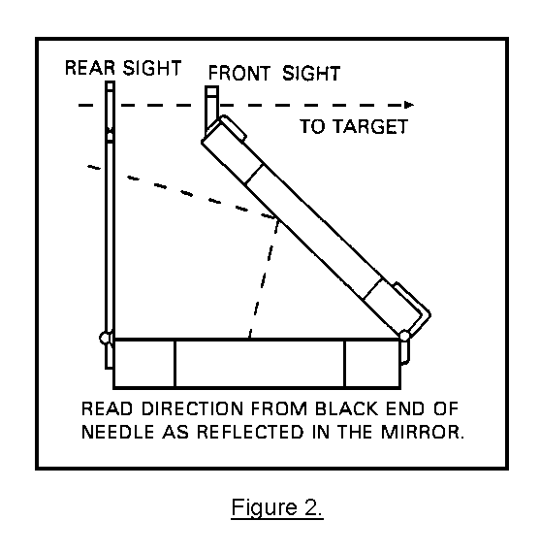
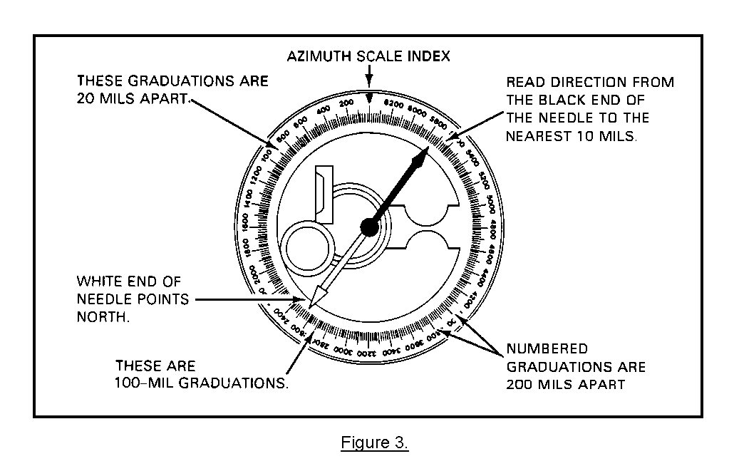
f. Refer to Figure 3. Notice that the scale (reflected) is marked every 20 mils and numbered every
200 mils. The longer graduations halfway between each numbered graduation represent 100 mils. Direction is interpolated to the nearest 10 mils.
PRACTICE EXERCISE:

Complete the following exercise as appropriate. Be sure to complete the practice exercises as they appear. They are "building blocks" and will help you complete the rest of the subcourse successfully. The answers follow the last exercise. If any of your answers are incorrect, restudy the appropriate part of the subcourse before you continue.
1. Read the direction from the illustrated azimuth scales below, and write your answers.
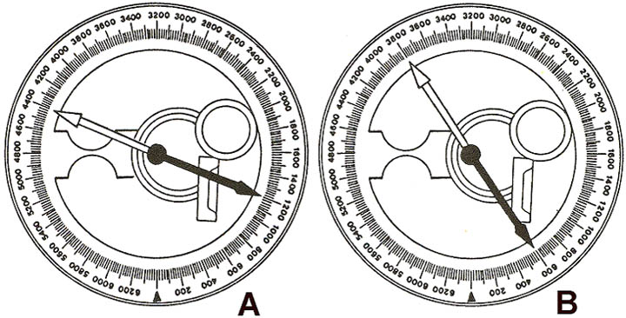

ANSWERS:
1. a. 4,390 (± 10 mils)
b. 0620 (± 10 mils)
3. CARDINAL DIRECTION. When a better method is not available, target direction may be reported by cardinal direction (north, northeast, east, south-east, south, southwest, west, or northwest) (Figure 4).
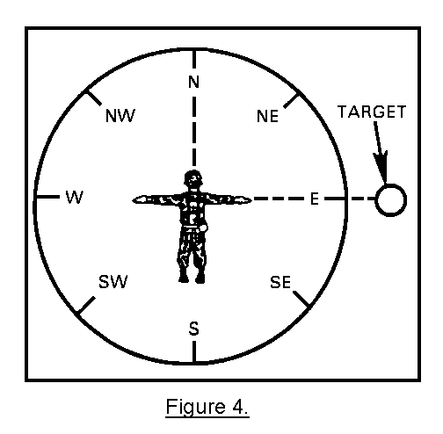
PRACTICE EXERCISE:

2. From the following illustration, the target direction reported to the FDC would be cardinal direction _________________________________.
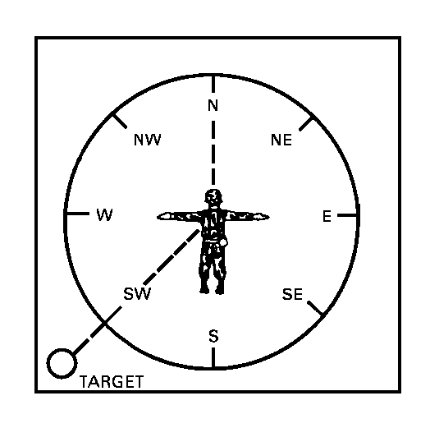
ANSWER:

2. southwest.

4. MEASURING ANGULAR DEVIATION. When a compass is not available, target direction may be determined by measuring the angle between the target and a nearby reference point, the direction of which is known by the observer and the FDC, and then applying the measured angle to the known direction using the right add--left subtract (RALS) method (Figure 5).

• If the target is to the right of the reference point, the measured angle is added to the known direction.

• If the target is to the left of the reference point, the measured angle is subtracted from the known direction.

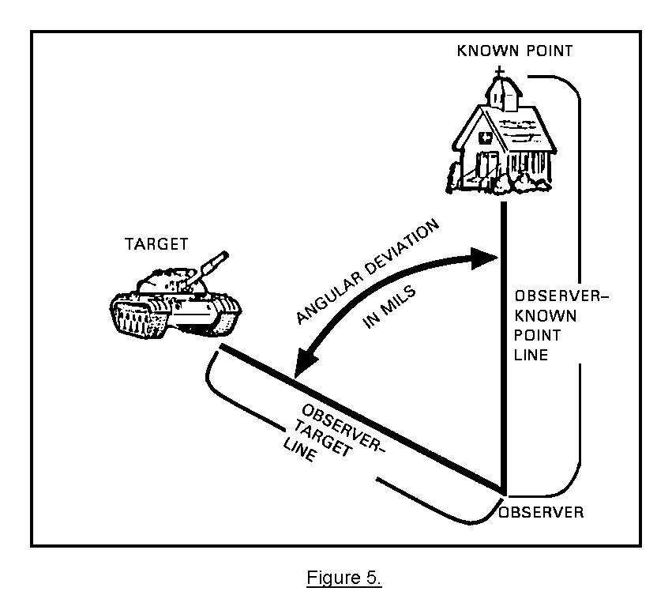
a. The best way to measure angular deviation is with the horizontal scale of your binocular reticle pattern. The horizontal scale is graduated in 10-mil increments starting in the center of the scale and going both left and right 50 mils (Figure 6).
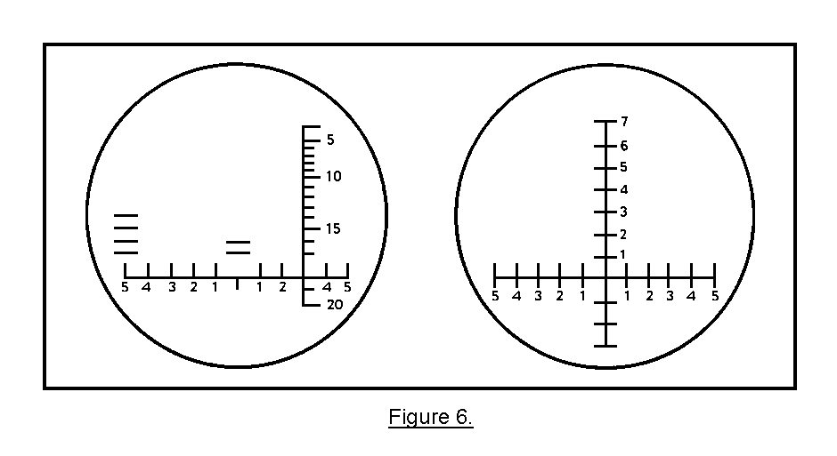
The first illustration in Figure 6 is the entire binocular reticle pattern for some of the older type binoculars. The newer type has a reticle pattern as shown in the second illustration. Either pattern may be used to measure angular deviation. For simplification, only the horizontal scale is shown in Figures 7 and 8. To determine angular deviation--
• Align the center of the scale with the known point. | 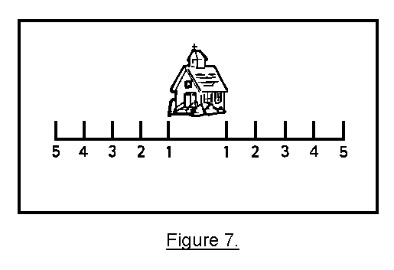
• Determine which numbered graduation is in line with the center of the target. | 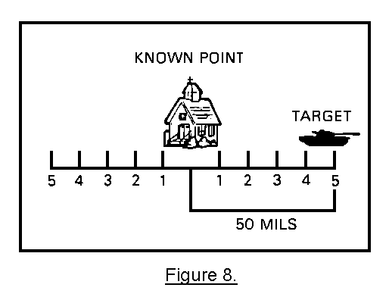

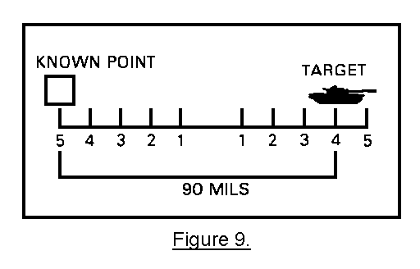
Sometimes the known point and the target may be so far apart that you cannot align the center of the horizontal scale with the known point and still measure the angular deviation to the target. When this happens, move the horizontal scale to the left or right until both the known point and the target are covered by the scale (Figure 9). Measure the number of mils between the known point and the target.
When the known point and the target are more than 100 mils apart--
• Move the horizontal scale to the left or right, as appropriate, until the known point is located at one end of the scale (Figure 10). | 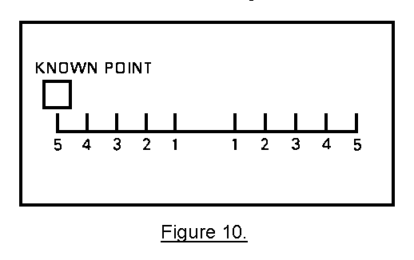

• Find an easily identifiable object near the target end of the scale. This object will become your reference point (Figure 11). | 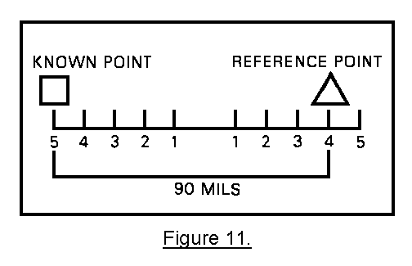
• Measure the number of mils from the known point to the reference point. Then, move your binoculars until the reference point appears at the end of the scales where the known point was located (Figure 12). | 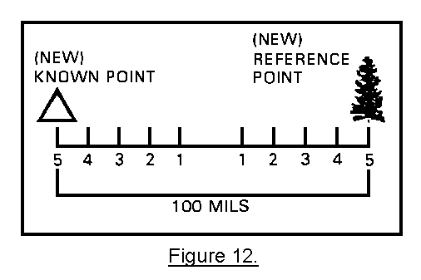
• Repeat the procedure until the target appears on the scale. Then measure the number of mils from the last reference point to the target (Figure 13). | 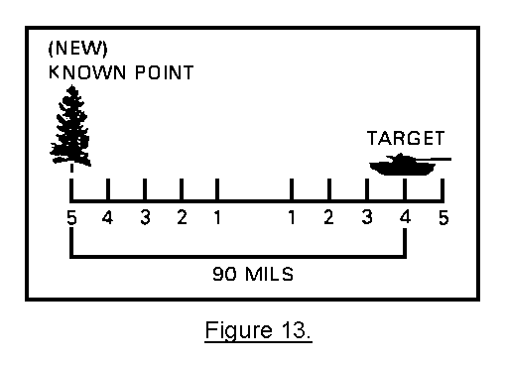
• Add the total number of mils between the known point/reference point(s)/target (Figure 14).
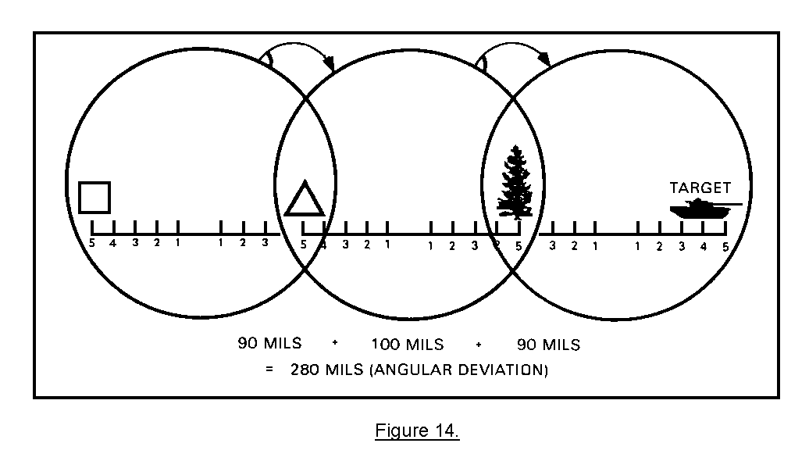
NOTE: Do not use this method if the angular deviation is more than 600 mils.

b. When it is necessary to measure angles quickly, the observer may use the hasty method. The observer should fully extend his arm so that his hand and fingers are always at the same distance from his eyes. The palm of his hand is always pointed toward the target area (Figure 15). In addition, he should calibrate his hand and fingers to determine the values of the angles for the various combinations of fingers and positions shown in Figure 15. | 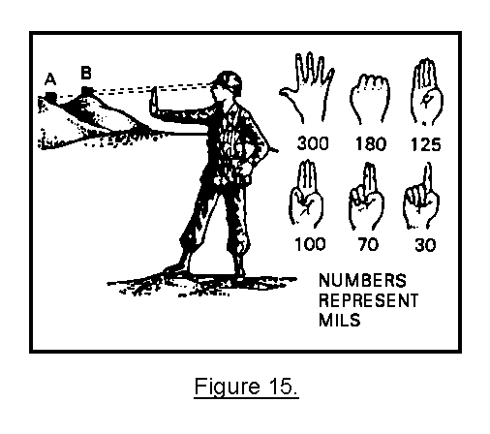
Refer to Figure 16. The observer measures the angle between the known point and the target as the width of his closed fist. The approximate angular deviation is 180 mils, assuming that the observer has calibrated his fingers and hand as shown in Figure 15. | 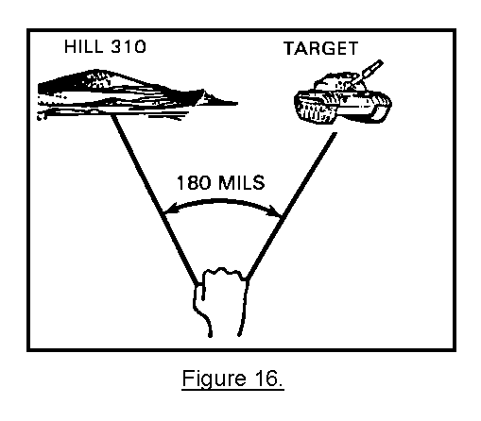

PRACTICE EXERCISES:

3. Determine the angular deviation between the known point and the target as depicted in each of the following illustrations.

a. ________________ mils b. __________________ mils
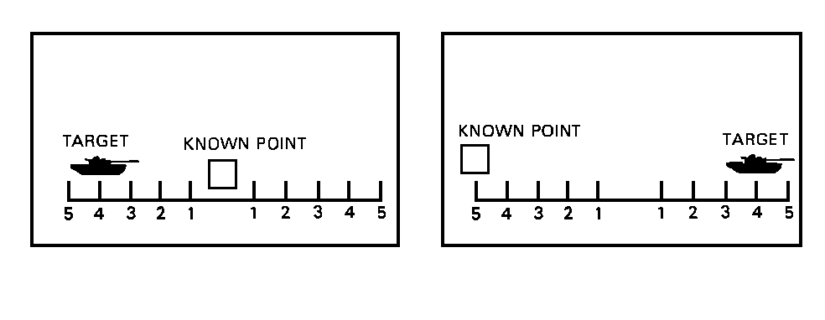

c. ________________ mils d. ________________ mils
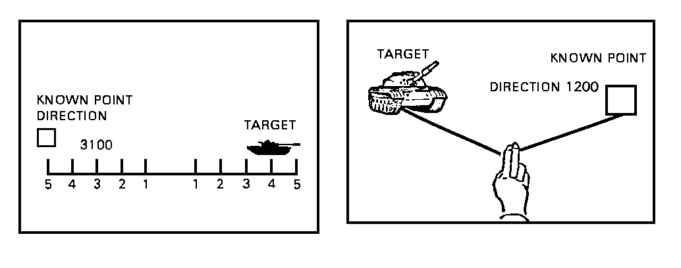
ANSWERS:

3. a. 40
b. 90
c. 90
d. 70

5. RIGHT ADD--LEFT SUBTRACT. Once you have measured the angular deviation, determining the direction to the target is simple. Just apply the angular deviation to the known point direction using the right add-left subtract (RALS) rule. Refer to Figure 17.
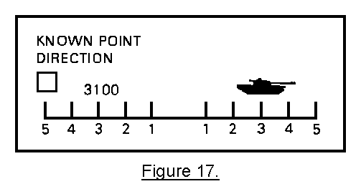
The target is to the right of the known point; therefore, we add the angular deviation to the direction to the known point.

3100 (known point direction)
+ 80 (angular deviations)
3180 (target direction)

PRACTICE EXERCISE:

4. Determine the target direction using the information depicted in the following illustrations:

a. __________________ mils b. ________________ mils
ANSWERS:

4. a. 3,180 (3,100 + 80)
b. 1,130 (1,200 - 70)

6. SCALING FROM A MAP. Using a protractor, the observer may scale direction from a map to an accuracy of 10 mils. There are several types of protractors, but the two types seen most often are shown in Figure 18. A protractor is provided for you at the end of this subcourse.
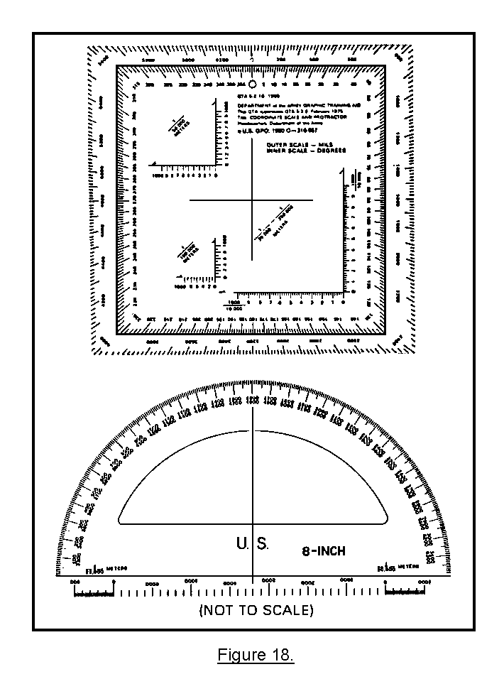
a. The transparent protractor has an inner scale in degrees (0° to 360°) and an outer scale in mils (0 to 6,400 mils). The center of the protractor is marked by the intersection of the horizontal and vertical lines forming the shape of a cross hair. The inner degree scale is divided into 1° increments and labeled every 5°. The outer mil scale is divided into 20-mil increments and labeled every 200 mils. Refer to Figure 19.
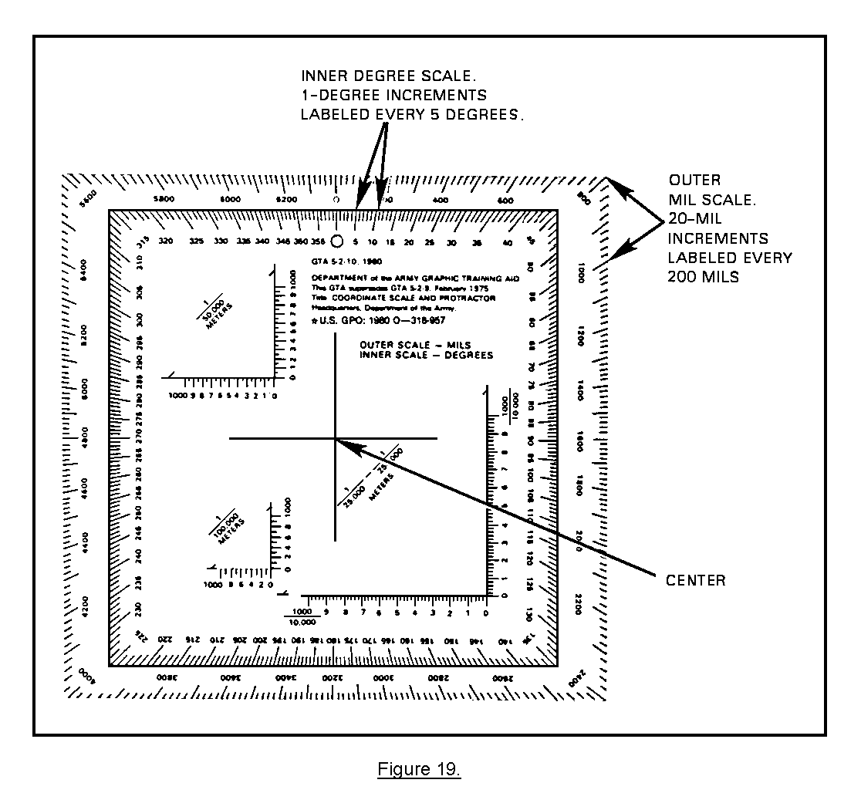
The observer will use the mil scale in determining direction. The inner triangular scales are used in determining grid coordinates and are discussed in Lesson 2 of this subcourse.

b. To use the protractor properly, draw a straight line (azimuth line), using a straightedge, from the observer's location to the target location.

NOTE: For the scale to be read, the line drawn between the two points must be long enough to cross the scale(s) of the protractor. If the line between the two points is too short to cross the scale(s), extend the line beyond the target location until it crosses the scale(s) (Figure 20).
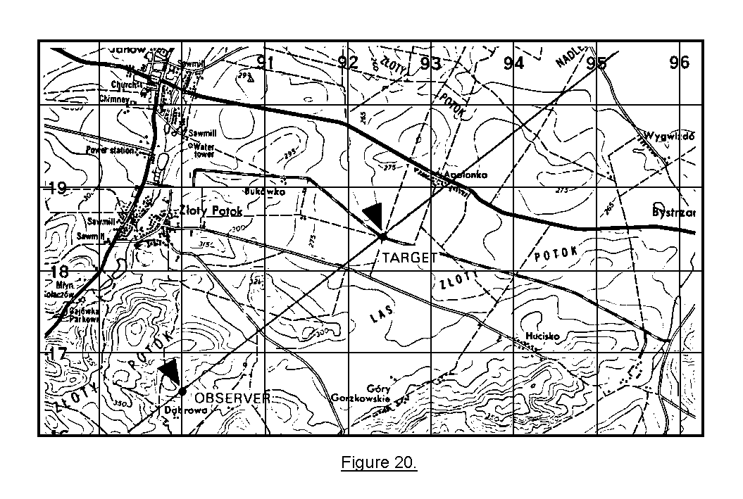
c. To orient the protractor on the map--

• Place the center cross hairs over the observer's location on the map with the 0- to 6,400-mil index oriented north.

• Align the 0 to 3200 center cross hair line parallel to a north-south grid line and the 1600 to 4800 center cross hair line parallel to an east-west grid line.

An example of a properly oriented protractor is shown in Figure 21.

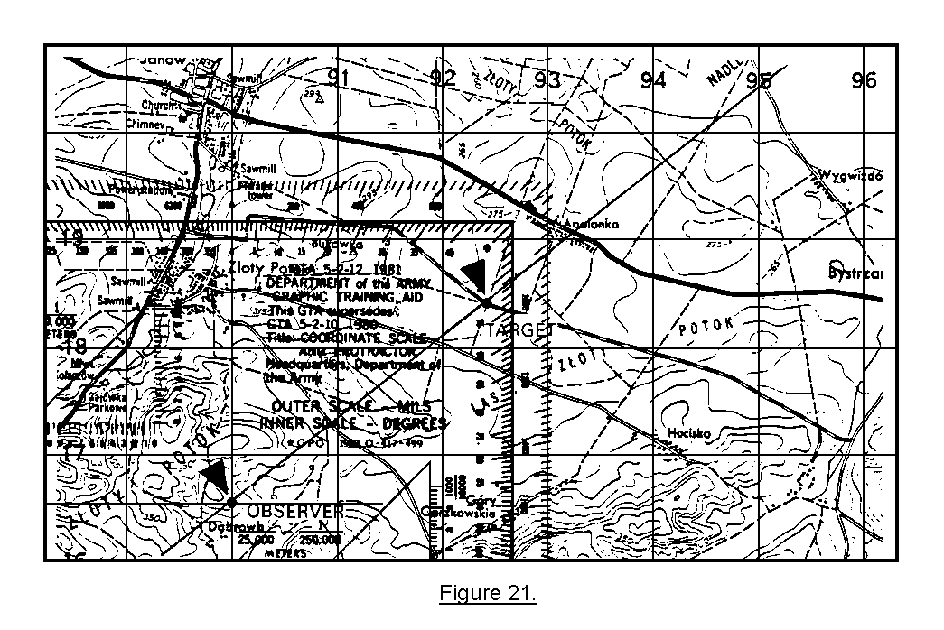
d. Start at the 0-mil mark on the protractor, and read to the right (clockwise) until you reach the point at which the azimuth line crosses the scale(s) of the protractor. At that point read the azimuth. In Figure 22, the azimuth is 920 mils.
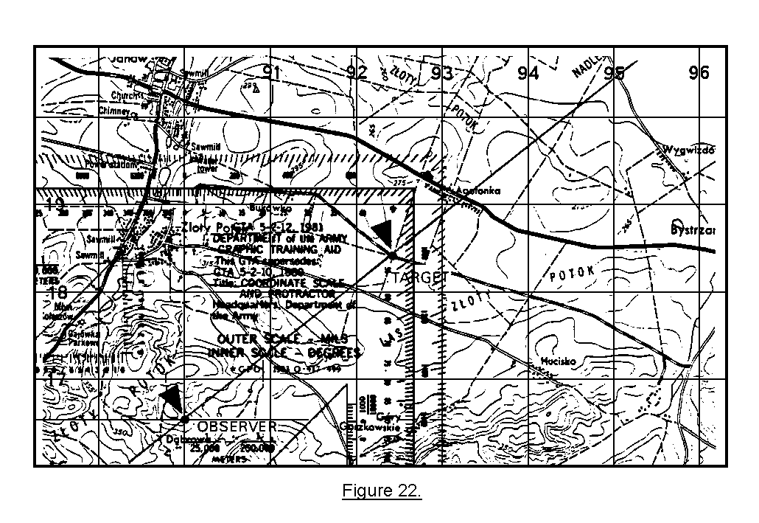

7. USING OTHER MEASURING DEVICES. When properly oriented, the aiming circle, battery commander's scope, or G/VLLD will provide directions to the nearest mil. The heading indicator, or compass in an aircraft, can be used by the aerial observer.

8. SUMMARY. Determining direction is an essential skill for the observer. Direction is an integral part of terrain-map association, adjustment of fire, and target location. The five methods of determining direction are estimating, scaling from a map, using a compass, measuring from a reference point, or using other measuring devices.

LESSON 2

LOCATE A TARGET BY GRID COORDINATES

OBJECTIVE

After completing this lesson, you will be able to determine target locations by the grid coordinate method.

9. INTRODUCTION. The preferred method of target location used by an observer is the grid coordinate method. Using this method, the observer associates the actual ground location of the target with a point on a military map. Grid coordinates are always expressed in an even number of digits. The number of digits in the coordinates tells the accuracy to which they are located.

EXAMPLES:

Four digits--8498 - These four digits are coordinates of a grid square and are located to an accuracy of 1,000 meters. When the coordinates are broken down, 84 is the easting and 98 is the northing.

Six digits—841981 - This is a set of grid coordinates expressed to the nearest 100 meters. When the coordinates are split in half, 841 becomes the easting and 981 becomes the northing.

Eight digits—84129812 - These coordinates are expressed to the nearest 10 meters. This tells us that 8412 is the easting and 9812 is the northing.

10. ESTIMATING COORDINATES. Refer to Figure 23. To estimate coordinates, imagine a 1,000-meter grid square as being further divided into 100-meter squares. Then you can estimate grid coordinates to the nearest 100 meters.
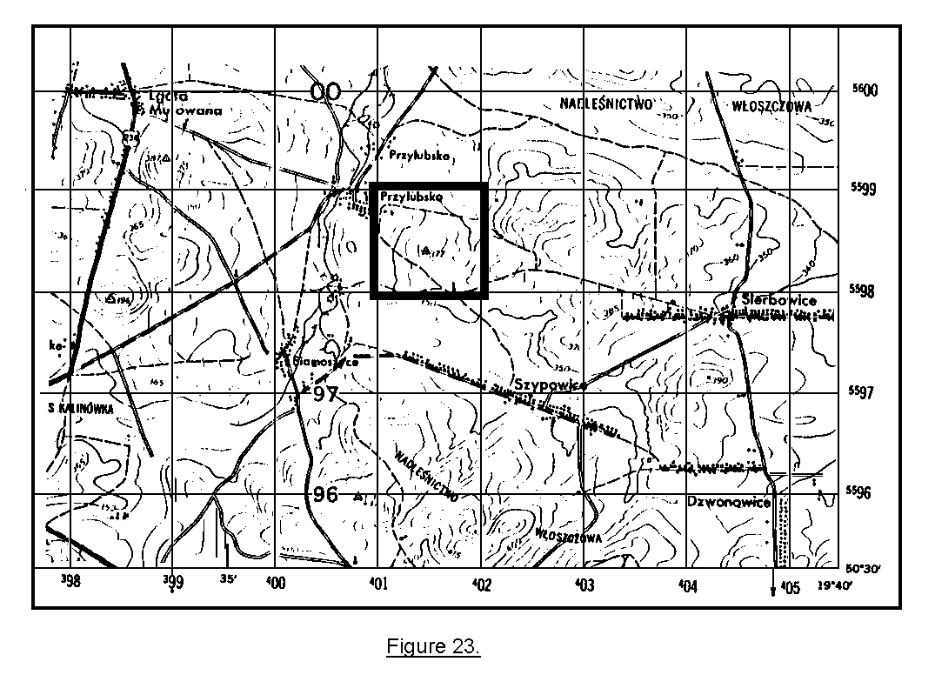
PRACTICE EXERCISE:

5. Refer to your ZARKI map to locate grid square 0198. Within that grid square is a small triangle with a black dot in the center (-). That is a horizontal control point (HCP). Break that grid square down, and estimate the coordinates of the HCP. See the illustration below.

Refer to the figure below, and see how that grid square would appear if it were divided into 100-meter squares.
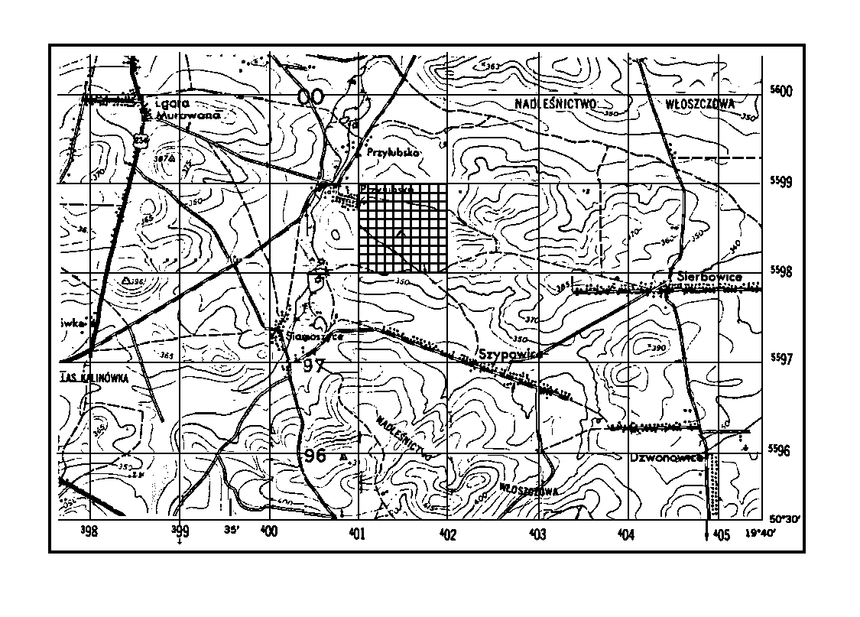
ANSWER:

5. 015984

The fifth vertical line to the right was past the HCP, but it was closer to the center than the fourth line. The fourth horizontal line runs almost through the center of the HCP. Put the easting and northing values together. Your coordinates of the HCP are 015984.

PRACTICE EXERCISE:

6. We have drawn the 100-meter squares in one of the grid squares on the map below. In the space provided, write the grid coordinates of the abandoned mine symbol ( ) in the overprinted grid square. Express the coordinates to the nearest 100 meters.

Grid coordinates __________________________________
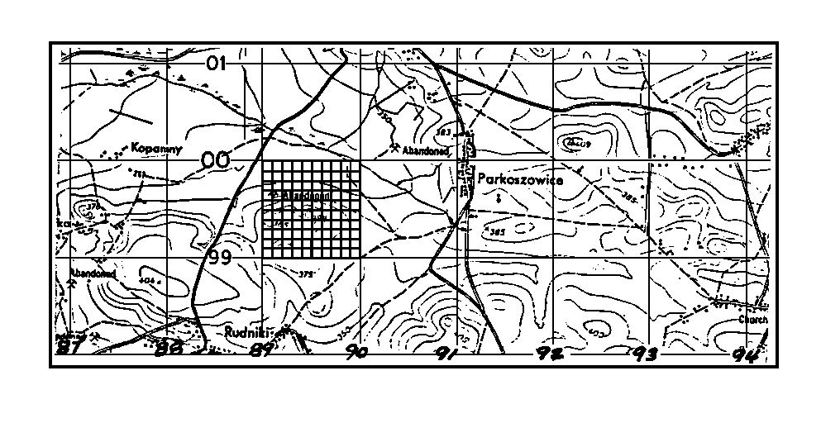
ANSWER:

6. 891996 (± 100 meters in easting or northing)

11. ESTIMATING COORDINATES WITHOUT OVERPRINTED 100-METER SQUARES.
If all the 1,000-meter grid squares were overprinted with 100-meter squares, estimating coordinates would be easy. Try estimating coordinates without the overprinted 100-meter squares.

PRACTICE EXERCISES:

7. On your map sheet, locate grid square 9201. In that grid square is a symbol for an HCP (-). Write the coordinates that you estimate to the center of the HCP in the space below. Estimate the coordinates to the nearest 100 meters.

Grid coordinates ________________________________
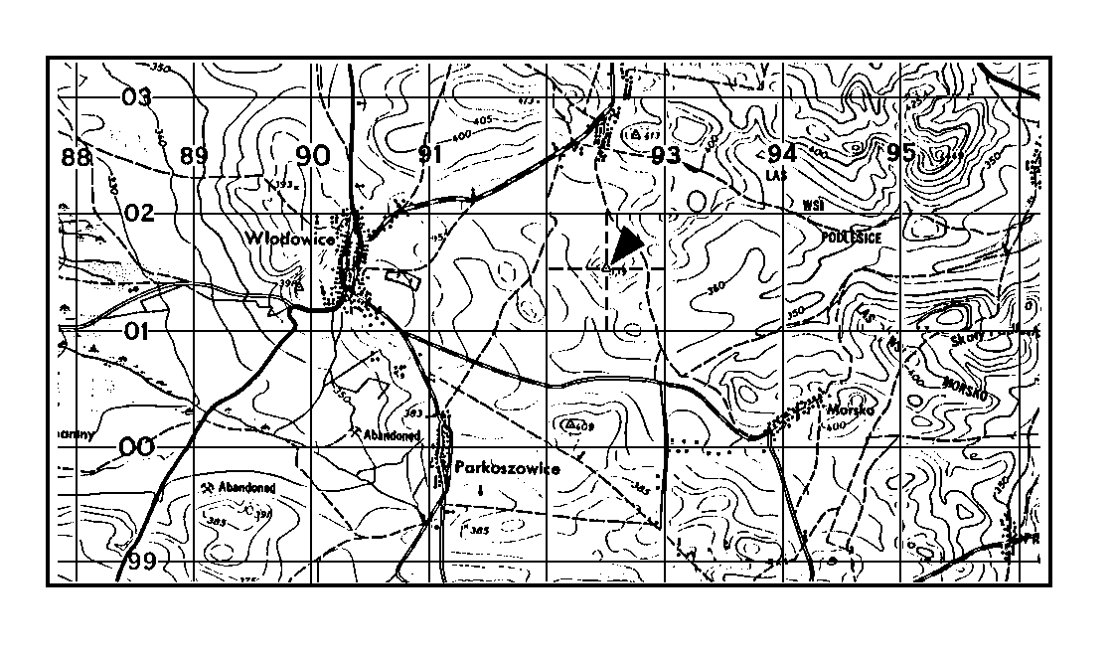
ANSWER:

7. 925015 (± 100 meters easting and/or northing)

This one was easy, since the HCP was almost in the center of the grid square. We drew dotted lines vertically and horizontally through the HCP. This enabled us to estimate the distance right and up from the bottom left corner of the grid square to the HCP.

PRACTICE EXERCISE:

8. Estimate the coordinates of the HCP indicated by the large arrow on the map illustration below to the nearest 100 meters. Write your answer in the space provided.

Grid coordinates __________________________________
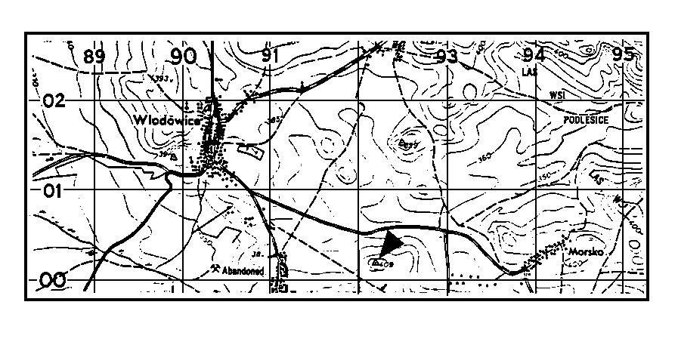
ANSWER:

8. 922002 (± 100 meters easting and/or northing)

Again we drew dotted lines through the HCP to help make our estimation. It is not good practice to mark on a map, but you can if it will help you be more accurate.
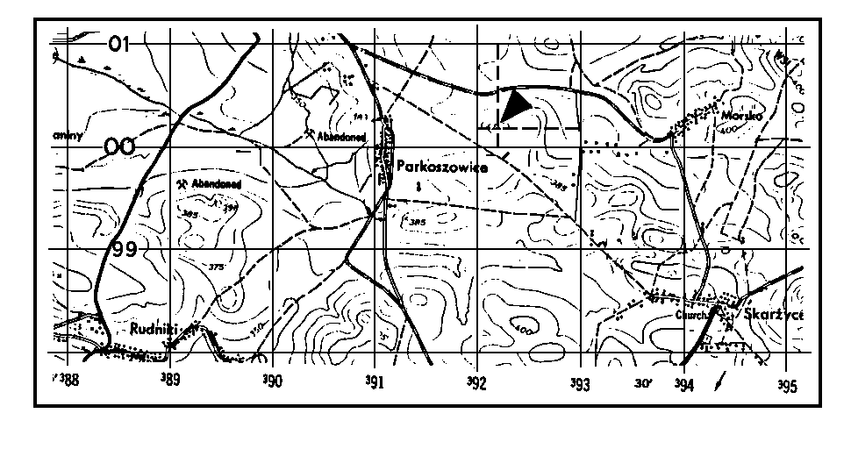

12. MEASURING GRID COORDINATES. Measuring the grid coordinates is done by using the inner triangle-shaped scales of the transparent protractor or by using a plotting scale. The most common plotting scale is illustrated below with the protractor (Figure 24). A plotting scale is provided for you at the end of the subcourse.
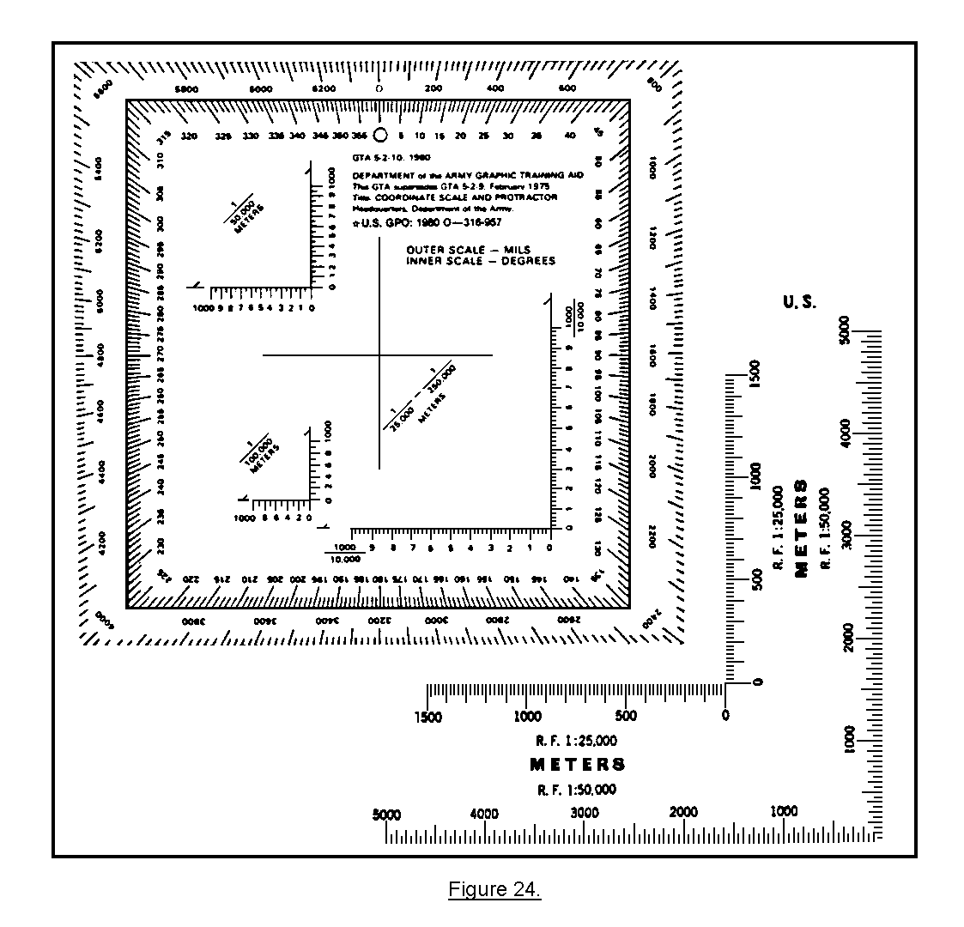
The plotting scale is divided into 50-meter increments and labeled every 1,000 meters. In using a plotting scale, it is not necessary for the observer to estimate in dividing the grid square into 100-meter squares. The observer can determine the grid coordinates by using the movements on the plotting scale.

PRACTICE EXERCISE:

9. Measure the grid coordinates to the HCP (Target 1) and the Hilltop (Target 2) indicated by the arrows in the map illustration below. Write your answers in the space provided.
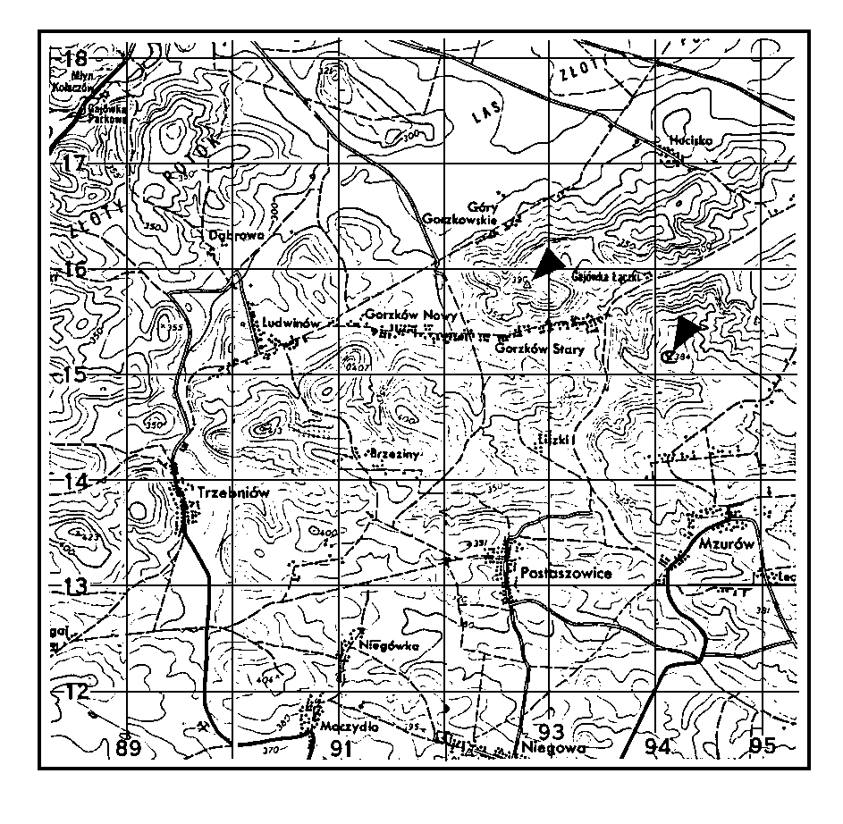
Coordinates: Target 1--HCP _________________________________

Target 2--Hilltop ___________________________
ANSWER:

9. 928158 (± 100 meters easting and/or northing)
941151 (± 100 meters easting and/or northing)

If you had trouble determining these grid coordinates, review the entire exercise. If you correctly determined the coordinates or have reviewed and now understand how to measure grid coordinates, continue.

13. TERRAIN FEATURES. Terrain features are defined as hills, valleys, ridges, roads, road junctions, buildings, or anything that can help you identify your area. Identifying man-made objects as they appear on your map is usually not difficult. The legend on your map will help identify any of the man-made features you may not recognize. The legend appears at the bottom left margin. Terrain features that are not man-made such as hills, valleys, ridges, etc., are represented on military maps by use of contour lines. Contour lines are the brown lines overprinted on your map sheet. They show the shape of terrain features as they would appear as you look down on them. Contour lines also express altitudes on a map. (See subcourse FA 4023-09, Map Reading II.)

PRACTICE EXERCISES:

10. Refer to the legend of your ZARKI map sheet, and match the map symbols in column A with the definitions in column B. Write the number of the definition of your choice in the space beside each symbol.
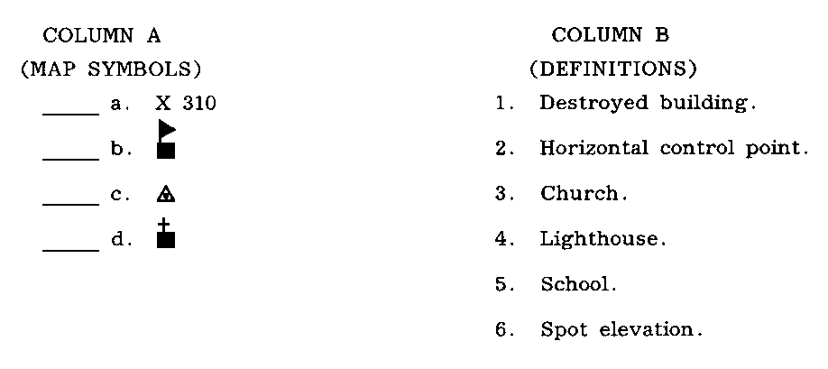
11. On your ZARKI map, identify the prominent terrain features, either natural or man-made, found at the grid coordinates listed below. Write your answers down.

COORDINATES TERRAIN FEATURE

a. 885135 ______________________

b. From 009018 to 030028 ______________________

c. 851166 ______________________

d. 925160 ______________________

e. From 938158 to 959172 ______________________

f. 910149 ______________________

ANSWERS:

10. a. 6
b. 5
c. 2
d. 3

11. a. Hill
b. Ridge
c. Mine
d. Draw
e. Valley
f. Saddle
14. TERRAIN ASSOCIATION. Before you can estimate or measure grid coordinates of a target, you must be able to determine where the target is located on your map. The map location of a target can be determined by associating the actual terrain features as they appear on your map to the location of your target. When terrain features are prominent and easy to see on the map, locating the target is easier.

PRACTICE EXERCISE:

12. SITUATION. You are an observer located on a hilltop at grid 911151. With your binoculars, you see a stalled tank in front of you as shown in the illustration. You measure the direction to the tank to be 0800 mils. On the map on the next page, determine the grid location of the tank. Write your answer in the space provided.
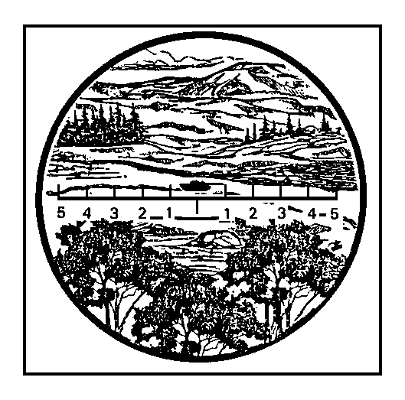
Grid coordinates _____________________________
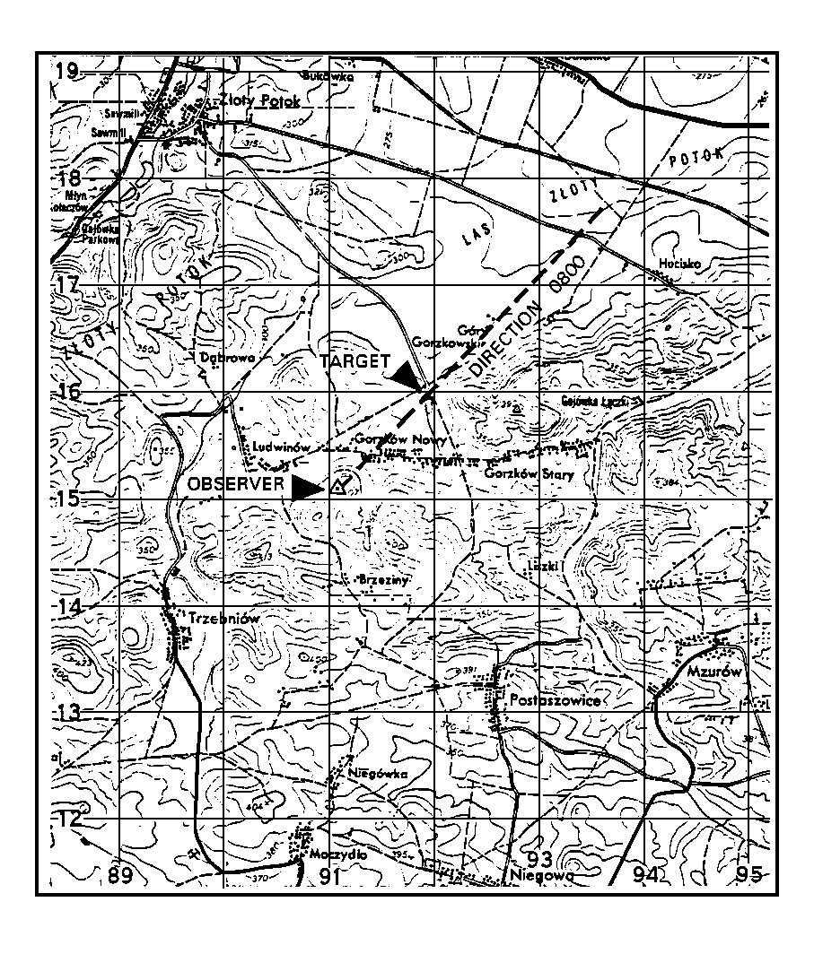
ANSWER:

12. 919160 (± 100 meters easting and/or northing)

You had only to follow the direction of 0800 mils out from the observer's position to the curve in the road and look a little past the road to find the hill behind the tank and the road. If you had any trouble, review practice exercise 12.

PRACTICE EXERCISES:

13. SITUATION. Refer to your ZARKI map. You are an observer located on a hill at grid 911151. You have spotted a helicopter on the ground as shown in the illustration below. The helicopter is northwest of your location at a distance of about 1,000 meters. Write the grid location of the helicopter in the space provided.

Grid ___________________________
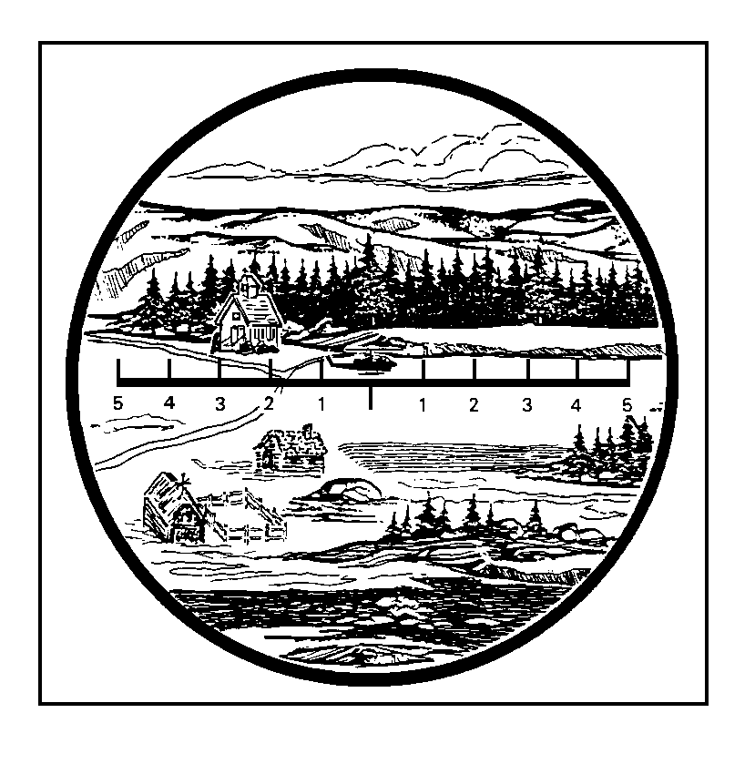
ANSWER:

13. Grid 901160 (± 100 meters easting and/or northing)

Establish the northwestern direction on the map, and look 1,000 meters in distance along that line. Then you find the curve in the road and the building. You have to look pretty close to determine which is the church, but these buildings are the only ones next to a curve in the road in that area. You will have to look closely to see the church.
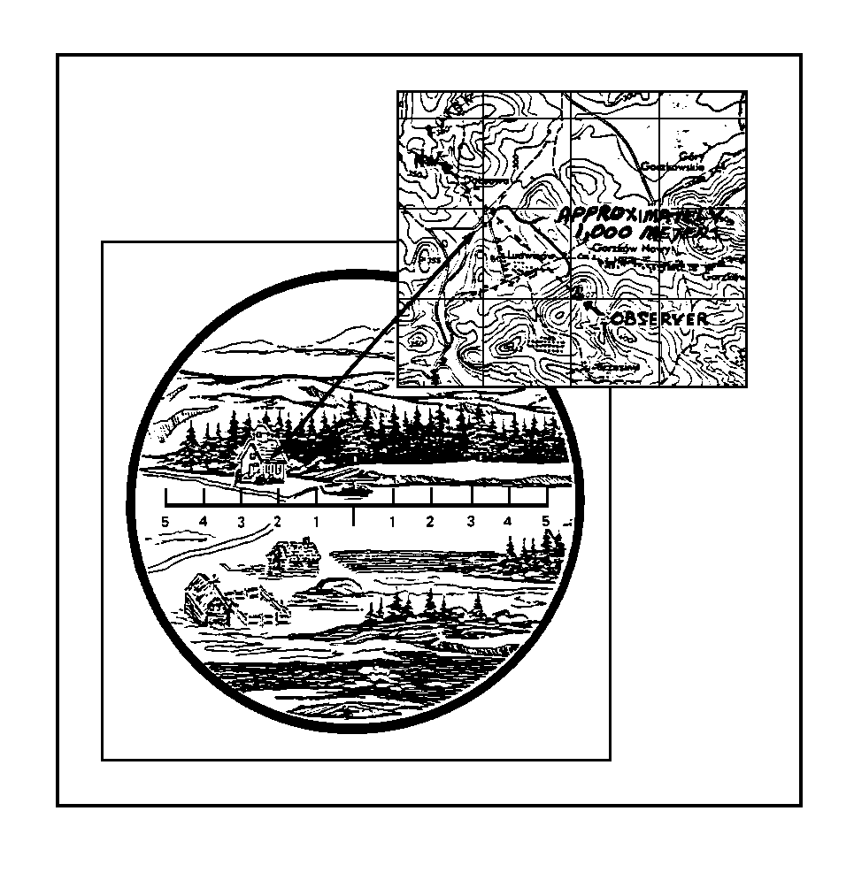
PRACTICE EXERCISES:

14. SITUATION. You are located on a hilltop at grid 907135, and your area of observation is to the north. You have spotted, through your binoculars, an enemy scout vehicle as shown in the illustration below.

Write in the space provided, the grid coordinates you determine for the enemy scout vehicle.

Grid coordinates __________________
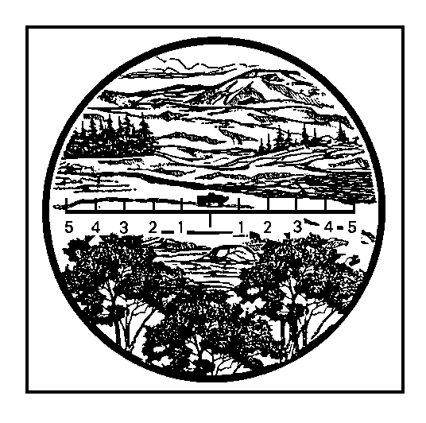
ANSWER:

14. 910146 (± 100 meters easting and/or northing)

To locate the scout vehicle, first establish the direction (north). Then look for the terrain features that you have seen through your binoculars--the curve in the road A, the hilltops B, C, and D, the orchard E. You can see the vehicle on the road and the hills are in the background. That will help you place the vehicle. Look at the illustration below. The prominent terrain features are lettered on the map and in the binocular illustration to help you associate them.
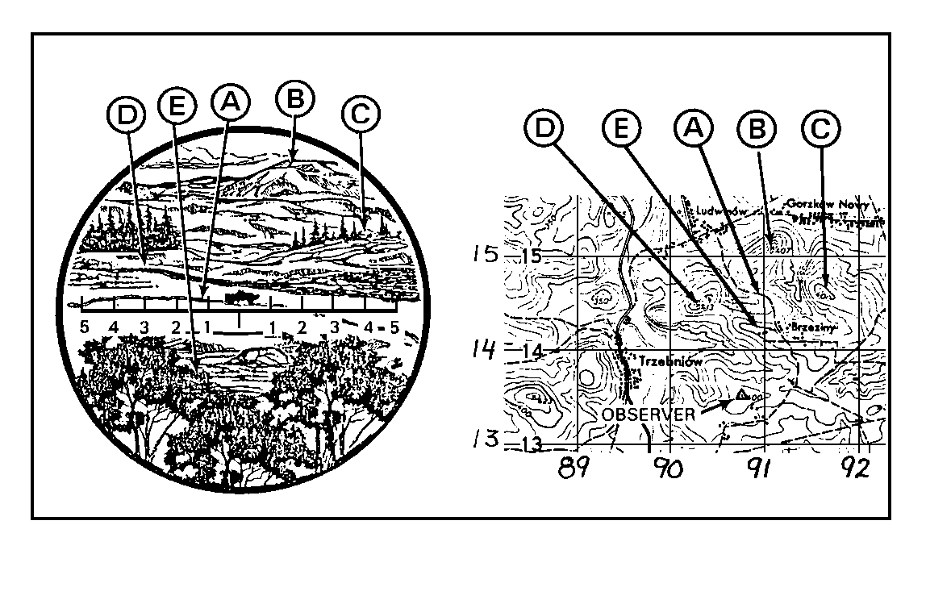
15. OBSERVER AIDS. There are several proven techniques and aids that can be used to help an observer locate targets. Some of the more common ones are as follows:

a. The observed fire fan. The observed fire fan helps the observer identify on the map the terrain he sees on the ground. The OF fan is a transparent protractor that can be used to show observer target (OT) direction and distance on the map. The OT direction is represented by radial lines that are 100 mils apart and cover a total of 1,600 mils (Figure 25). Radial lines can be labeled with a grease pencil for the appropriate direction.
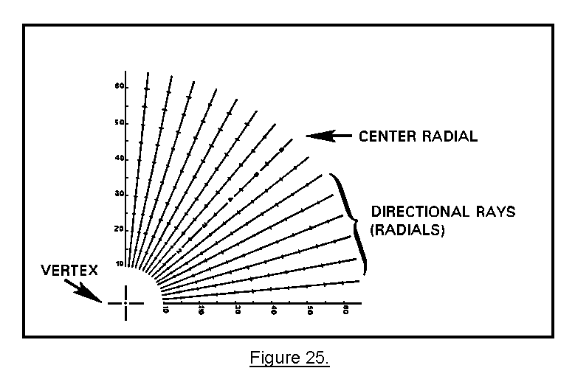
The radial lines extending out from the vertex have dashed arcs representing distances from the observer location. The dashed arcs intersect the radial lines at intervals of 500 meters, beginning at 1,000 meters and extending out to 6,000 meters. The center and outer radial lines are numbered every 1,000 meters for quick reference in determining distance from the vertex (Figure 26).
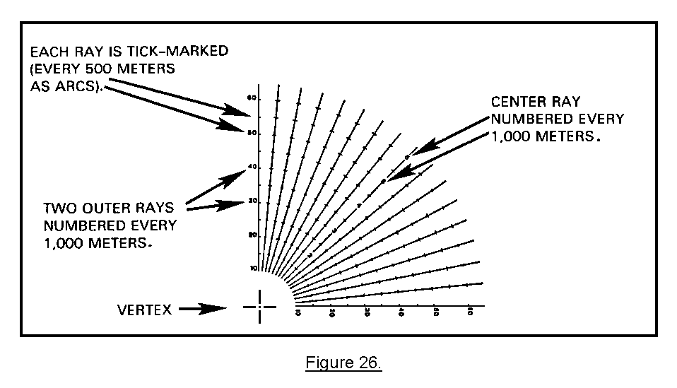
Remove the OF fan from the end of the subcourse, and use the map extract (Figure 27).
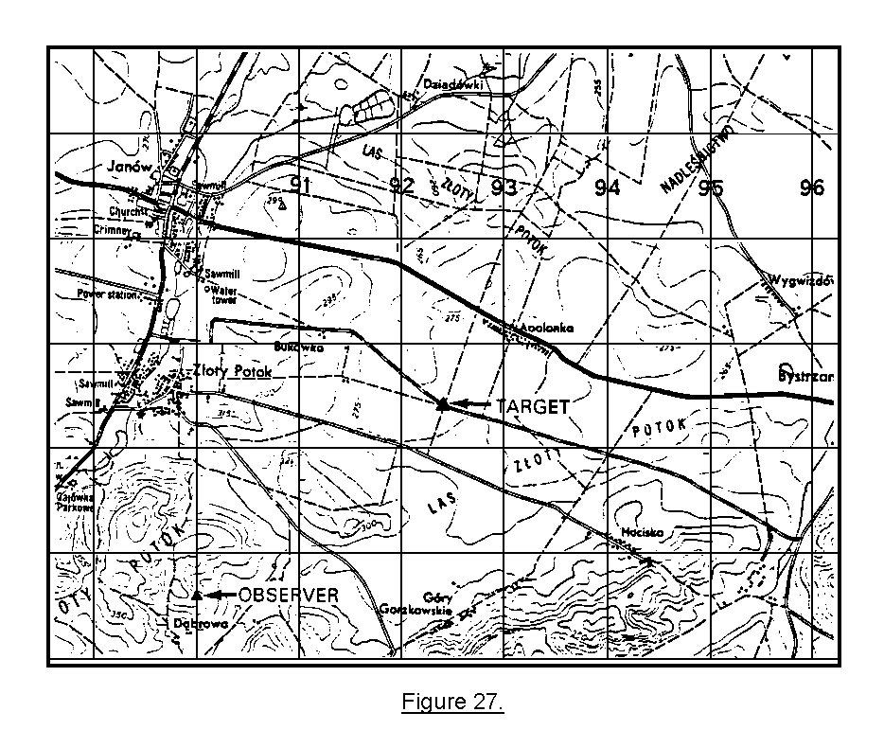
To orient the OF fan--

• Place the vertex over the observer's location on the map.

• Position the center radial of the fan in the direction of the center of the observer's sector of responsibility.

• Move the fan slightly until one of the radial lines is parallel to a grid line. The direction of that radial line is the same as the grid line. (A radial line parallel to a north-south grid line, with the OF fan oriented generally north, would be direction 6400 or 0).

• With a grease pencil, number the radial of known direction by dropping the last two zeros (1600 would be 16). Then, label every second radial with the appropriate direction. (Labeling every radial is unnecessary and makes the fan too cluttered.)

An example of a completed OF fan is shown in Figure 28.
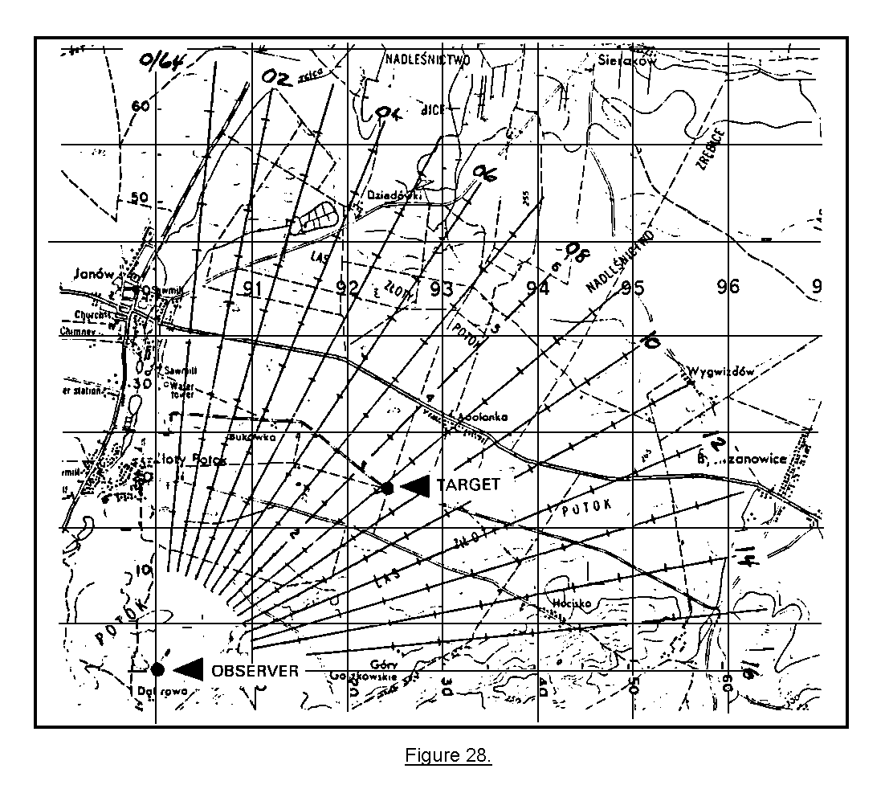
To determine target location using the OF fan--

• First, determine a direction to the target by quick use of a compass or other means of determining direction, and estimate the distance to the target.

• Find the two radials between which the direction falls, and visually interpolate between the two to determine the direction.

• Look along this interpolated radial line to the estimated distance. Mark this point.

• Compare the terrain near the target with the terrain on this estimated point on the map. If they agree, determine the point from the map. If they do not agree, search along the radial line until you find matching terrain. Then determine the grid.

NOTE: The target must be along the radial line representing the direction to the target.

The observer locates a target to his northwest at an estimated distance of 3,000 meters. He then plots the data on the OF fan by finding the two radial lines between which the OT direction falls and visually interpolating between the two to determine the OT direction. The observer follows this interpolated radial line until he has marked off the estimated point on the map. In this case, the target that appeared was on a small hill at a distance of 2,800 meters (interpolated from the OF fan). If the terrain around the map and around the target agree, the observer can determine grid coordinates to the target. In this case, the grid coordinates to the target are 909178. Using the plotting scale, plot the coordinates to see if we are within 100 meters easting and northing (Figure 29).
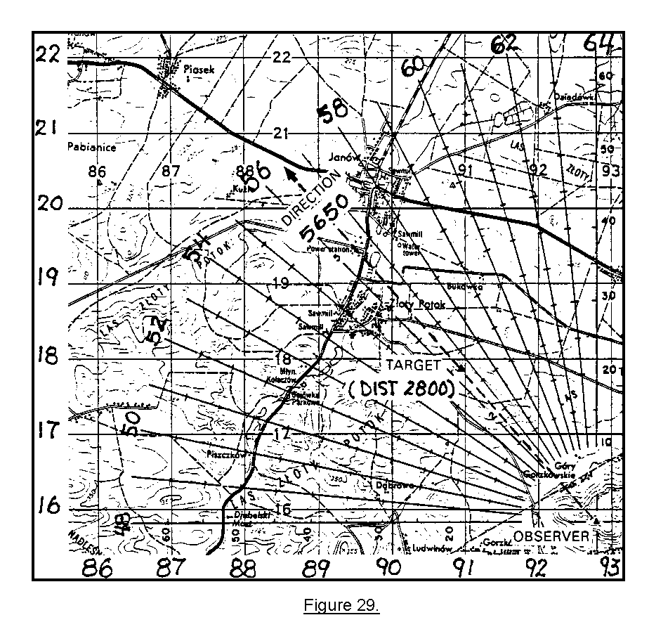
Figure 30 shows four OF fans that have been labeled to cover four different areas of observation. Refer to this illustration until you become familiar with labeling your OF fan for different areas.
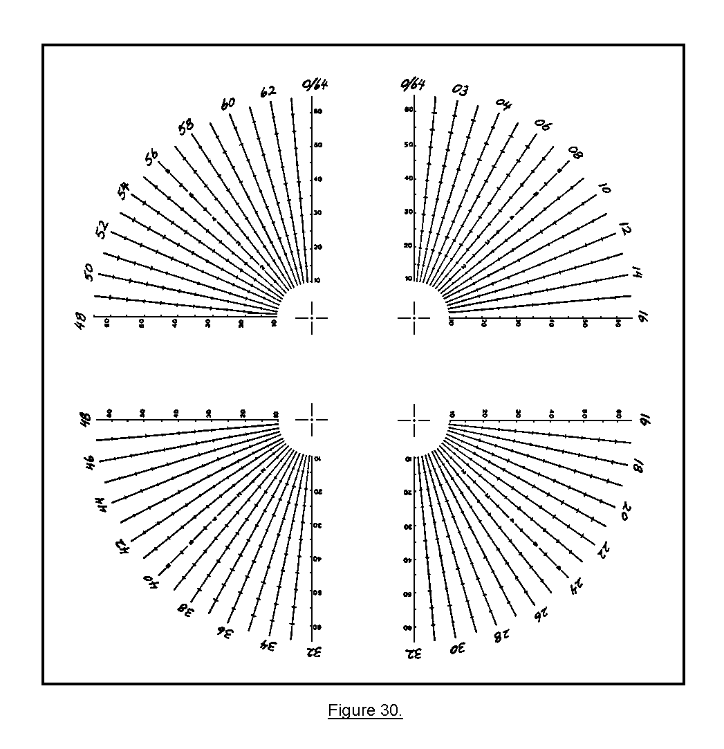
To measure a distance to a point with the OF fan, determine the distance to the tick mark nearest the target. If the target is between two tick marks, estimate the distance to the nearest 100 meters. Refer to the example in Figure 31.

The distance to Target A is 5,000 meters.

Grid coordinates ______________________________.
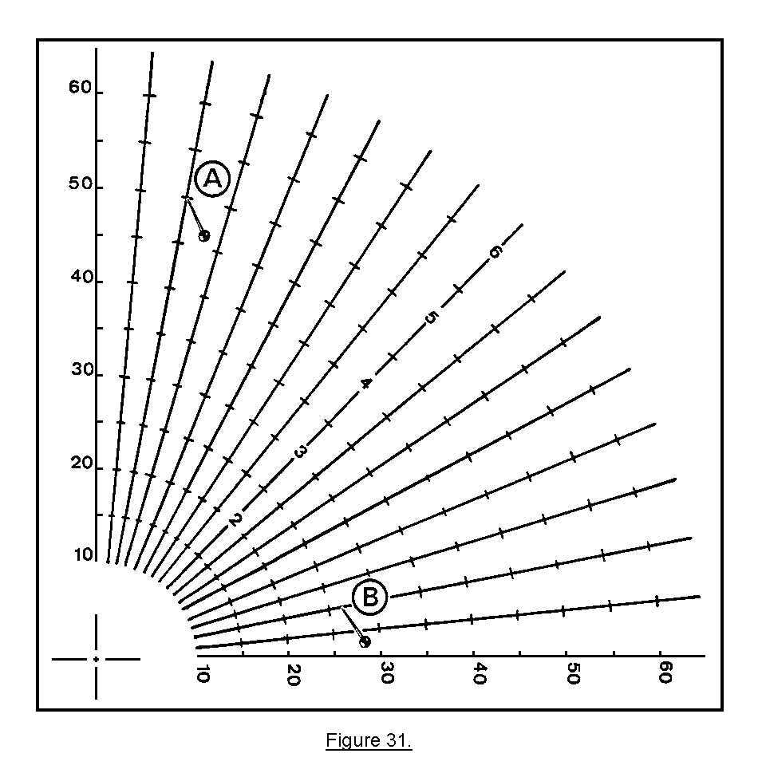
The distance to Target B is 2,700 meters.

Grid coordinates ______________________________.

PRACTICE EXERCISE:

15. SITUATION. You are an observer on Hill 314, and your OF fan has been oriented through your zone of observation (northwest). You see two targets to your front. Measure the direction to both targets with an M2 compass, and estimate the range to both targets. Correctly label your OF fan, and determine the grid coordinates to within 100 meters in easting and/or northing. Remember, your ranges are only estimated.

Target A--a stalled tank on a major road junction north of a cemetery, direction 5960, estimated range 2,000 meters.

Target B--an enemy OP on a hilltop, direction 5,190 mils, estimated range 3,800 meters.
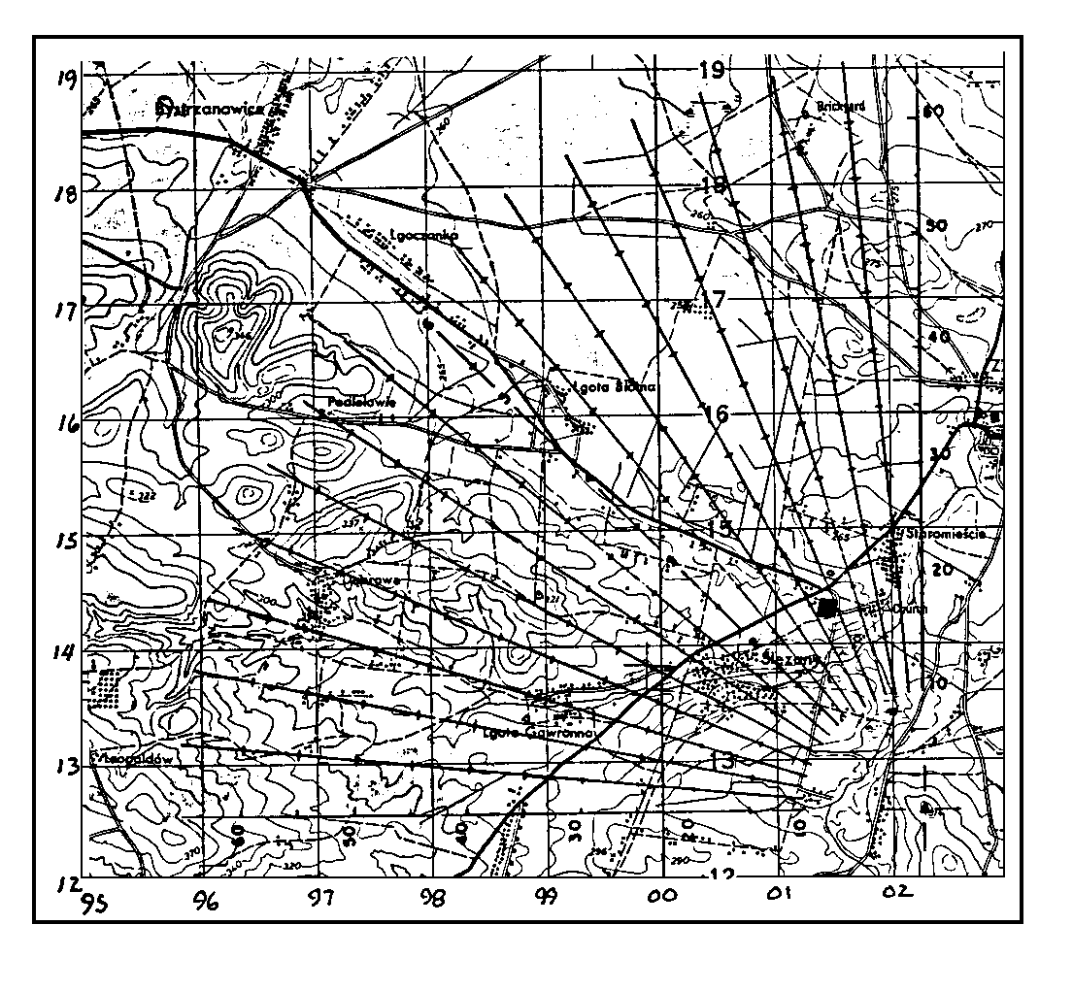
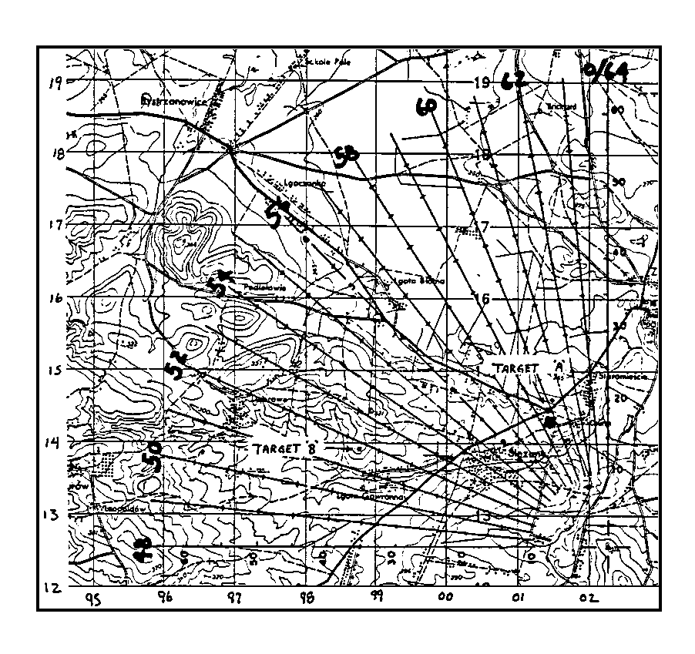
Write your answers in the spaces provided. You should be within 100 meters easting and/or northing.

Grid coordinates Target A _________ Target B ____________

ANSWERS:

15. Target A 014145 Target B 988139

Target A should not have been difficult to locate, because it was located at a major road junction and the range estimation was accurate. The terrain association was the road junction and the cemetery. Target B may have been more difficult because the range estimation was off by 300 meters. However, the terrain association of the target being on a hilltop should have been the clue you needed to locate the target, because there are no other hilltops on that line of direction. If you had any problems with locating the targets to within 100 meters easting and/or northing, review practice exercise 15. If not, continue.

PRACTICE EXERCISE:

16. SITUATION. Refer to your ZARKI map. You are an observer located at the HCP in grid square 9899, and the center of your zone of observation is southeast. You locate a large group of infantry digging in around a group of buildings with a watermill at each end of the buildings. You measure the direction with your compass to be 2,250 mils, and estimate the distance to be 2,000 meters. Orient and label your OF fan on your map, and obtain the grid coordinates to the nearest 100 meters.

ANSWER:

16. 006981 (± 100 meters easting and/or northing).
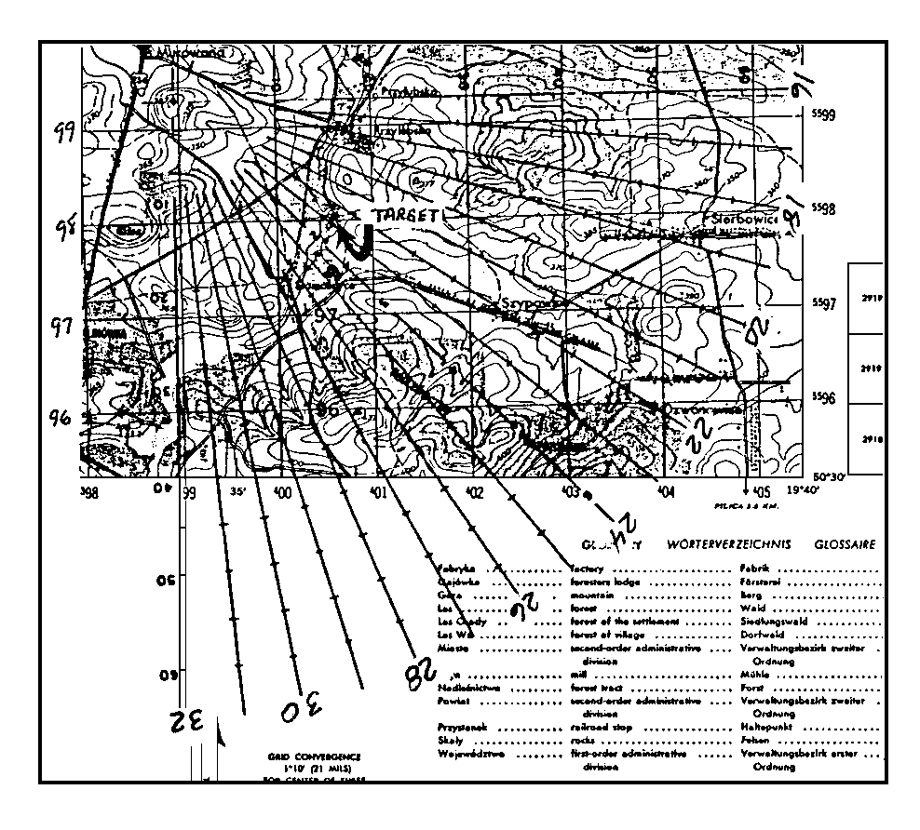
b. Terrain sketch. A terrain sketch is a rough panoramic sketch of the terrain in the observer's zone of observation (Figure 32). The sketch does not have to be a work of art but should be understandable to others. It should include such terrain features as valleys, hill masses, woods, roads, streams, and any man-made objects in the zone. Directions and distances should be included when they are known, and the sketch should be improved on as time allows.
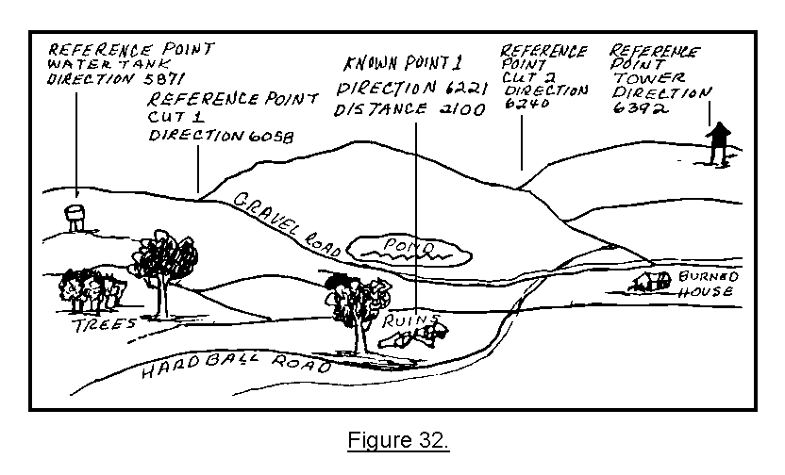

c. Hasty (hand-finger) method of measuring angular deviation. If the need arises, the observer may use his hand and fingers as an aid to measure angles quickly (Figure 33). This method is far from being as accurate as a compass but may be used in an emergency.  • The observer should calibrate his hand and fingers to determine the actual values of the various combinations of finger and hand positions shown in Figure 33. | 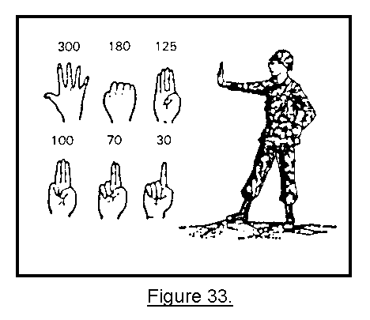

• When using his hand or fingers to measure angles, the observer's arm should be fully extended so that the hand and fingers are always the same distance from the eyes. The palm of the hand is always pointed toward the target area.

16. SUMMARY. Using the grid coordinate method of target location, the observer normally locates targets to an accuracy of 100 meters (six-place grid). The OF fan, terrain sketch, or hasty method of measuring angular deviation are aids which the observer may use.

LESSON 3

LOCATE A TARGET BY POLAR PLOT

OBJECTIVE

After completing this lesson, you will be able to--

• Determine the direction to the target and express it to the nearest 10 mils.

• Determine the distance to the target within ± 100 meters of the actual distance.

• Determine any obvious difference in altitude of the target location and altitude of the observer's location, and compute this vertical shift to the nearest 5 meters.

17. INTRODUCTION. The easiest method of target location for an inexperienced observer is the polar plot method. The observer does not need a map; however, his position must be known to the FDC. The principal advantage of the polar plot method is the ease and quickness with which the observer can determine target locations. The disadvantage is that the observer may reveal his location to the enemy. In addition, in a mobile situation, it may become difficult for an observer to always provide his location to the FDC.

18. DESCRIPTION. Polar coordinates consist of the observer-target (OT) direction, OT distance, and vertical shift (if any). The target location element will always consist of at least two parts--the OT direction and the OT distance. When the difference in altitude between the observer's location and the target is greater than 30 meters, the vertical shift should be included.

DIRECTION 1600, DISTANCE 2500, UP (DOWN) 40

When the difference in altitude between the observer's location and the target location is less than 30 meters, the vertical shift is ignored.

DIRECTION 1600, DISTANCE 2500

19. DETERMINING DIRECTION. Determining direction is an essential skill of the observer. Direction is an integral part of map-terrain association, adjustment of fire, and target location. As discussed in Lesson 1, there are five methods used to determine direction.

a. Estimating. With a map-terrain analysis of his zone of observation, the observer can estimate direction on the ground. As a minimum, the observer should be able to visualize the eight cardinal directions (N, NE, E, SE, S, SW, W, NW).

b. Scaling from a map. Using a protractor, the observer may scale direction from a map to an accuracy of 10 mils.

c. Using a compass. Using an M2 or lensatic compass, the observer can measure direction to an accuracy of 10 mils. Care must be taken around radios, power lines, and large concentrations of metal such as vehicles. Observers should move approximately 50 meters from such objects to avoid incorrect readings.

d. Measuring from a reference point. Using a reference point with a known direction, the observer can measure horizontal angular deviations and apply them to the reference direction. Angular deviations may be measured with binoculars or with the hand. These methods will be discussed in Lesson 4.

e. Using other measuring devices. When properly oriented, the aiming circle, battery commander's scope, or laser devices will provide direction to the nearest mil. The heading indicator or compass in aircraft also can be used by the aerial observer (AO) in determining direction.

PRACTICE EXERCISES:

17. The three elements of a polar plot target location are ________, _______________, and ______________ __________________.

18. As a minimum, the observer should be able to visualize the _______________________ _____________________ ____________________.

ANSWERS:

17. direction, distance, vertical shift.
18. eight cardinal directions.

20. DETERMINING DISTANCE. The second step in locating targets by the polar plot method is to determine the distance from the observer's position to the target. There are several methods of determining distance.

a. Scaling from a map. Using an OF fan or protractor, the observer may scale distance from a map to an accuracy of ± 250 meters of the actual target location.

b. Estimating. The only way to become proficient at estimating distances is through experience and knowledge of the zone of observation. There are a couple of methods that may help in estimating distances.  (1) One way to estimate distance is to imagine that you are standing at one end of a football field looking toward the other end. The distance of one football field is a little less than 100 meters. Estimate the number of football fields between you and the target, and then multiply by 100. For example, if you estimate that there are eight football fields between you and the target, the distance to the target, would be 800 meters (Figure 34). | 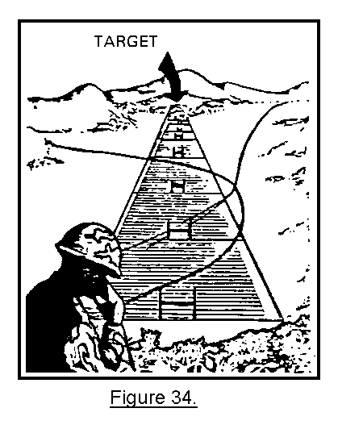
(2) Another method relies on the appearance-of-objects method. Naturally, the closer you are to an object, the larger it appears. To become proficient at judging distance requires practice. Practice judging distance using an object by looking at it from various distances. For example, a truck at a distance of 1,000 meters may be 10 mils wide in your binocular reticle pattern, and the same truck at 2,000 meters may only be 5 mils wide in the binocular reticle pattern. This method is best practiced in the field. Start with objects to which you already know the distance.

c. Flash-to-bang. When it is necessary to verify OT distance, the flash-to-bang technique is helpful. Sound travels at a speed of 350 meters per second. When the round impacts, multiply by 350 the number of seconds between the sight of the detonation (flash) and the sound of the detonation (bang). The answer is the approximate number of meters between the observer and round impact. Use the following equation:

ELAPSED TIME BETWEEN IMPACT AND SOUND X 350 = DISTANCE

This method also can be used to determine the distance to enemy weapon muzzle flashes.

d. Laser devices. Laser devices provide distance determination to an accuracy of ± 10 meters; however, they take time to set up or may not always be available.
PRACTICE EXERCISES:

19. SITUATION. You are an observer and have spotted a target on which you want to fire artillery. You decide to locate the target by the polar plot method. With your compass, measure a direction of 5,810 mils to the target. You estimate the distance to be 14 football fields from your location. Write in the space below, the first two elements of the polar plot target location.
_______________________________ _______________________________

20. SITUATION CONTINUED. The first round impacts and is not on the target. You measured the flash-to-bang time to be 5 seconds. How many meters away from you did the round impact? Write your answer in the space below.
__________________________

ANSWERS:

19. direction 5810 distance 1400.
20. 1,750

- VERTICAL SHIFT. If there is a significant difference in altitude between the target and the observer's location, the observer should include it in his target location. If the target is at a higher altitude than his location, the observer must go up the difference in altitudes. If the target is at a lower altitude, he must go down the difference (Figure 35). A significant difference in altitude is an altitude difference greater than 30 meters.
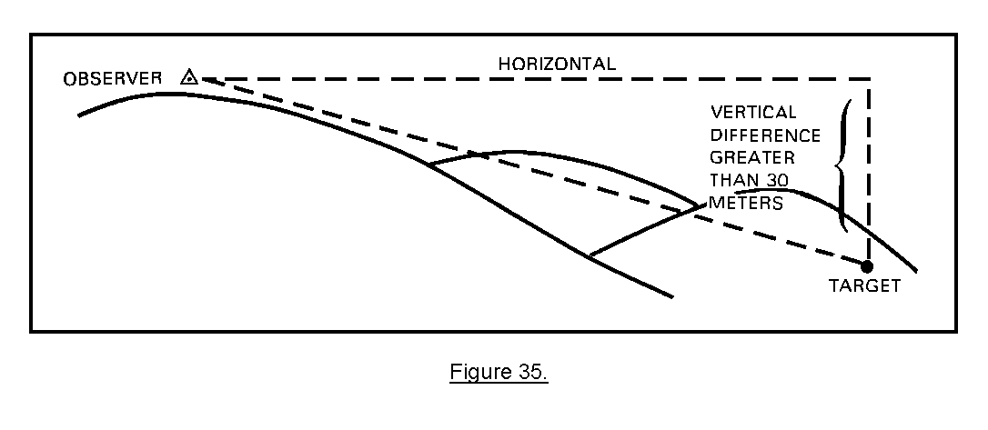
Vertical shifts are sent in 5-meter increments; for example, DOWN 35. Whether a vertical shift is sent or not, depends on several factors. If the mission is a fire-for-effect mission, a vertical shift should be sent to improve accuracy. If the observer does not have a map, vertical shifts are not sent. The observer should weigh the time expended on determining and sending a vertical shift against the time available. Experienced observers who can quickly determine differences in altitude should send a vertical shift when the difference in altitude is greater than 30 meters. When responsiveness is paramount, inexperienced observers should not attempt to send a vertical shift. Remember, the difference in altitude is expressed to the nearest 5 meters.

PRACTICE EXERCISES:

21. You should send a vertical shift as part of your polar plot target location when you determine the vertical difference is greater than _____________ ____________.

22. Vertical shifts are sent as either an ______ or a _______________.

23. Vertical shifts are sent to the nearest _________ _________.

ANSWERS:

21. 30 meters.
22. up, DOWN.
23. 5 meters.

22. SUMMARY. The easiest method of target location for an inexperienced observer is the polar plot method. The principal advantage of the polar plot method is the ease and quickness with which the observer can determine target locations. Determining direction and distance to targets is a skill essential to the observer. Also, the observer must know when to send the vertical shift (depending on the type of mission), how much time is available to determine and send the vertical shift, and whether to send a vertical shift if the difference in altitude is greater than 30 meters.

LESSON 4

LOCATE A TARGET BY SHIFT FROM A KNOWN POINT

OBJECTIVE

After completing this lesson, you will be able to--

• Determine an OT direction, and express it to the nearest 10 mils.

• Determine a lateral shift (left or right) from the known point to the target to the nearest 10 mils by using the mil relation formula.

• Determine a range change (add or drop) from the known point to the target to the nearest 100 meters.

• Determine a vertical shift (up or down) to the nearest 5 meters.

23. INTRODUCTION. An observer can locate targets by the shift from a known point method. A known point is an identifiable point with its location known to both the observer and the FDC of the supporting element. This method of locating targets can be used when the observer does not have a map or has difficulty locating targets on his map.

24. DESCRIPTION. The shift from a known point is the slowest of the three methods of target location. Before using this method, the FDC of the supporting element and the observer must know the location of the point from which the shift is going to be made. There are five elements used for location of a target by the shift from a known point method. A minimum of three must be used. The elements are listed below in the order in which they are sent to the FDC. The five elements are--

• Known point to shift from (always sent).

• Direction from the observer to the target (always sent).

• Lateral shift (if any).

• Range shift (if any).

• Vertical shift (if greater than 30 meters).

The known point and direction must always be a part of the target location, but the lateral shift, range shift, and vertical shift are sent only when necessary.

PRACTICE EXERCISE:

24. From the list below, check the elements of the shift from a known point method of target location.

_____ a. Vertical shift. _____ b. Coordinates. _____ c. Lateral shift.

_____ d. Distance. _____ e. Direction. _____ f. Range shift.

_____ g. Vertical angle. _____ h. Known point.
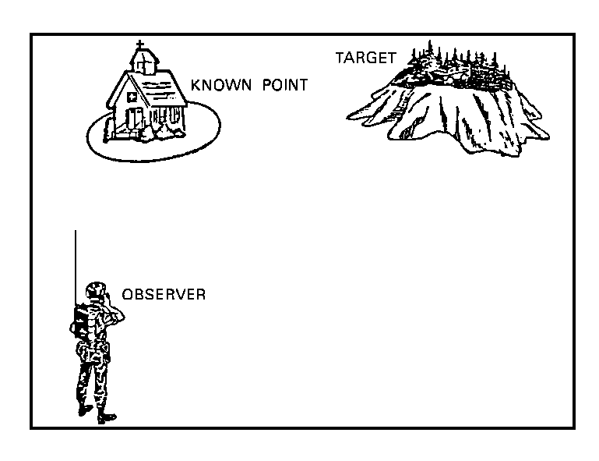
ANSWERS:

- a., c., e., f., h.

Elements are sent to the FDC in order.
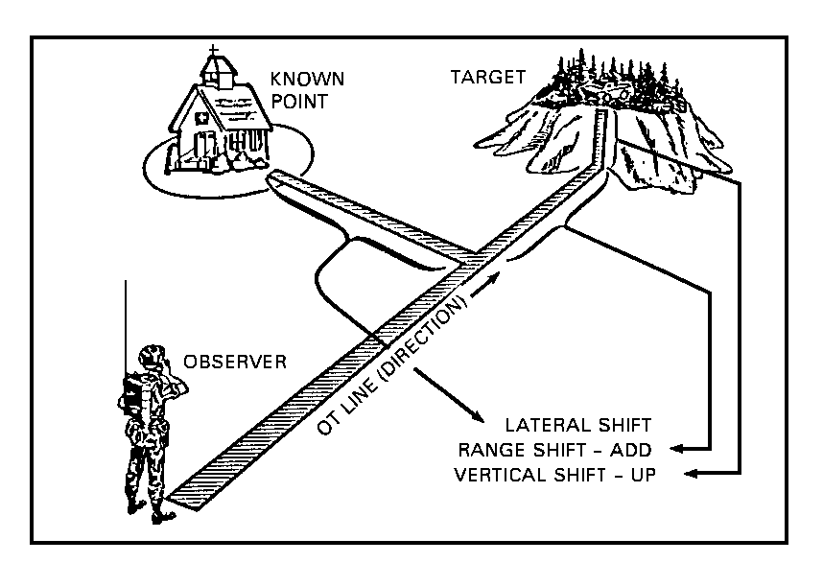
25. KNOWN POINT. A known point can be a target that has been previously fired on, a prominent terrain feature, a man-made structure, or any other terrain feature that both the observer and the supporting element FDC can identify on a map or by other means (survey, aerial photo, radar, etc.).
Remember, the supporting element FDC must know the location of the known point. Some examples of known points are--

• Registration points.

. Hilltops.

. Previously fired targets.

• Road junctions.

• Buildings.

• Bridges.

• River junctions.

In requesting fire from a supporting element and wishing to use the known point method, the word "SHIFT" and the point from which the shift is being made must be included in the request. For examples, SHIFT KNOWN POINT 1 and SHIFT TARGET AV7702.

PRACTICE EXERCISES:

25. T F The artillery firing unit must know the location of the known point.

26. T F A target that has been fired on may be used as a known point.

27. T F The word "shift" may be left out of a request for fire.

ANSWERS:

25. T
26. T
27. F

26. DIRECTION TO THE TARGET. The observer determines direction to the target on which to fire (not to the known point) by estimating or by measuring, usually to the nearest 10 mils. However, the FDC will be able to handle degrees or cardinal direction if necessary.

27. ANGULAR DEVIATION. When occupying a position, the observer usually makes a map-terrain analysis of the zone of observation. The purpose is to locate and measure direction to prominent, easily identifiable terrain features that can be found on the observer's map. If time permits, the observer may construct a terrain sketch and record the directions measured. When the observer has established direction to the known point, direction to the target can be measured by angular deviation. Angular deviation is the distance, in mils, left or right; the target is from the known point (Figure 36).
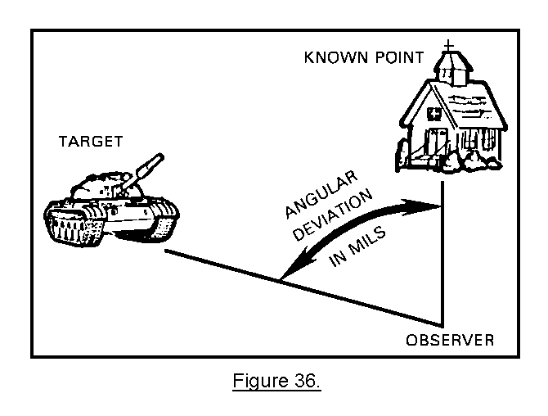
28. MEASURE ANGULAR DEVIATION. Several methods are available to measure angular deviation. One method is with the hand or fingers. The hand-finger method is a hasty method of measurement and is not as accurate as a calibrated instrument but may be used in an emergency. Certain fingers or combination of fingers and your hand represent so many mils. The observer should "calibrate" his hand and fingers to determine the actual values of the various combinations
of finger and hand positions. The observer can do this by measuring the mil value of an object with his hand or fingers and then doing it again with a set of binoculars. The measurement of mil values with binoculars will be discussed later in this lesson.

Look at the values given in Figure 37. You may find that the mil values of your hand and fingers vary a little from these.
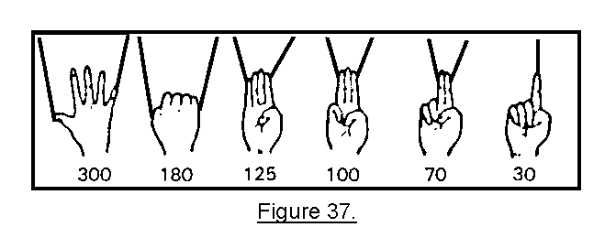

For the rest of the lesson, when using the hand or fingers to measure angles, the observer's arm should be fully extended so that the hand and fingers are always the same distance from his eyes. The palm of the hand is always pointed toward the target area (Fig 38). | 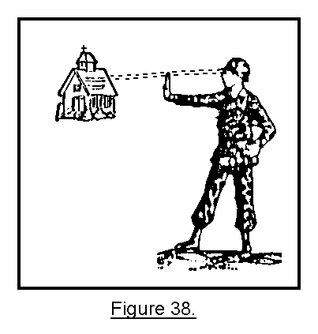
PRACTICE EXERCISES:

SITUATION. Using the hand-finger method of measuring angular deviation, determine the angle between the known point and the target shown in each of the illustrations below. Write your answers in the spaces provided.

28. Angular deviation _____________________ mils. | 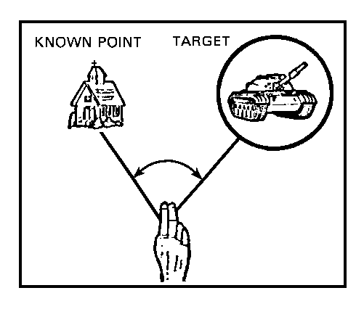
29. Angular deviation _____________________ mils. | 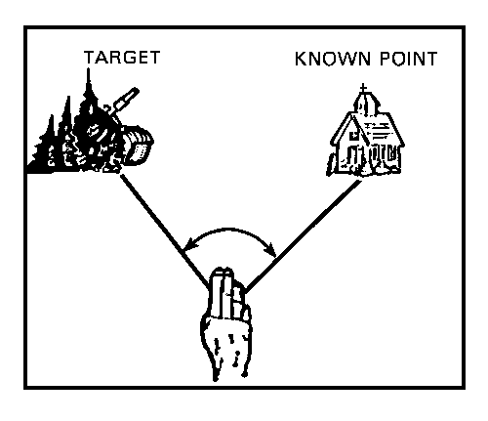
ANSWERS:

28. 70
29. 100

If you had problems determining the mil values of angular deviation, review practice exercises 28 and 29. If you had no problems, continue.

29. DETERMINE DIRECTION USING ANGULAR DEVIATION. Once angular deviation has been determined from the known point to the target, it is easy to determine direction from the observer to the target. Do this by adding or subtracting the angular deviation from the known point direction. This is called the RALS rule.

RIGHT ADD--LEFT SUBTRACT

If the target is to the right of the known point, add the angular deviation to the direction of the known point to determine the DIRECTION TO THE TARGET. If the target is to the left of the known point, subtract the angular deviation from the direction of the known point to determine the DIRECTION TO THE TARGET. Refer to Figure 39.
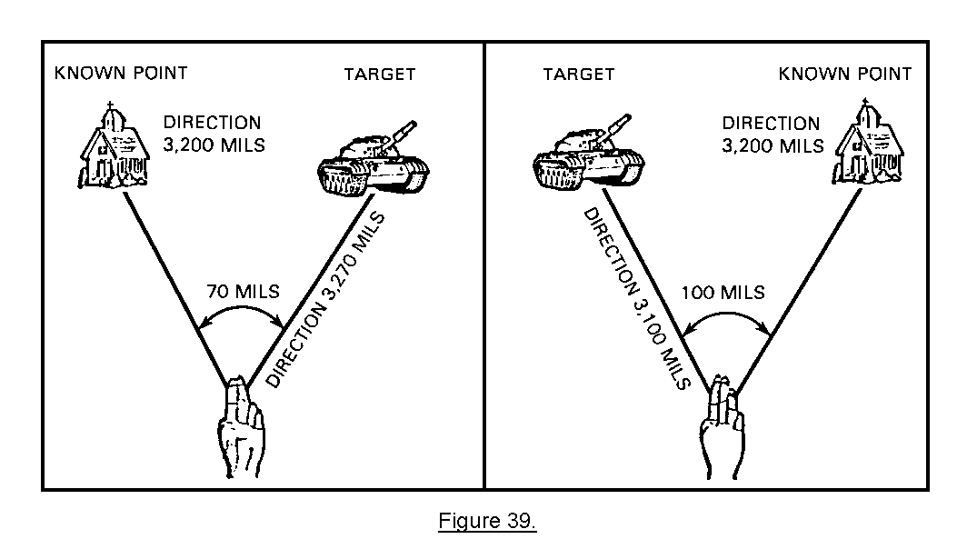
Since the target is to the right of the known point, add the angular deviation to the known point direction.

Known point direction + angular deviation = target direction (3,270 mils).

Since the target is to the left of the known point, subtract the angular deviation from the direction to the known point.

Known point direction – angular deviation = target direction (3,100 mils).

PRACTICE EXERCISES:

Write in the spaces provided the directions you determine from the illustrations below.

30. Direction _________________ mils
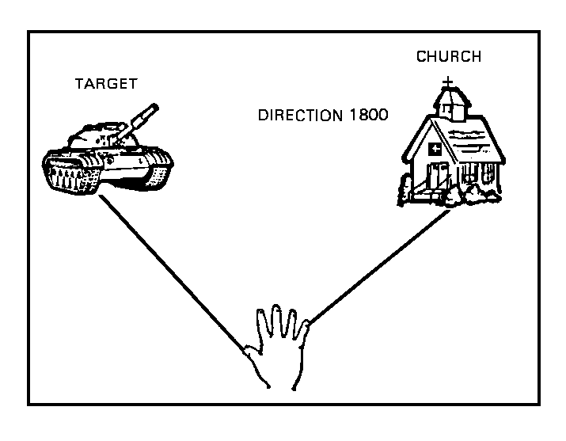
31. Direction _________________ mils.
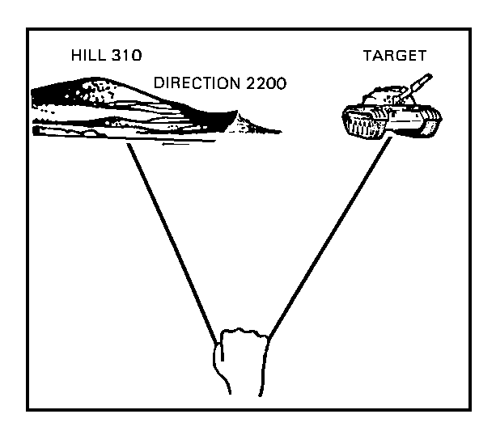
ANSWERS:

30. 1,500
31. 2,380

If you had any problems with practice exercises 30 and 31, review them. If you had no problems, continue.

30. MEASURING ANGULAR DEVIATION AND DIRECTION WITH BINOCULARS.
Another way to measure angular deviation is with the horizontal scale of the binocular reticle pattern. The first illustration below is the entire reticle pattern for some of the older type binoculars. The newer type binoculars have a reticle pattern as shown in the second illustration (Figure 40). Either pattern may be used to measure angular deviation.
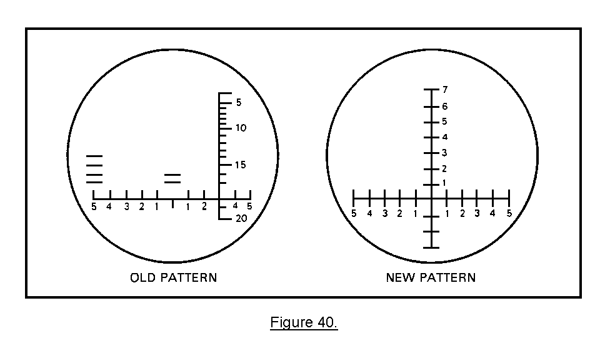
The horizontal scale is graduated in 10-mil increments starting in the center of the scale and going both left and right 50 mils, as shown in Figure 41. | 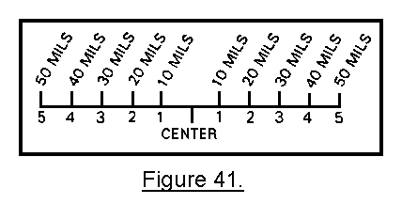
NOTE: For simplification, only the horizontal scale will be shown in the instructions below.

To determine angular deviation:

• Align the center of the scale with the known point (Figure 42). | 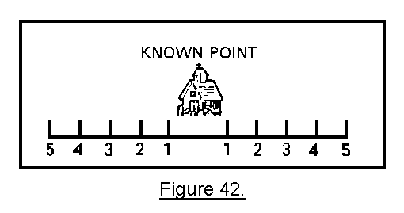

• Determine which numbered graduation is in line with the center of the target (Figure 43). | 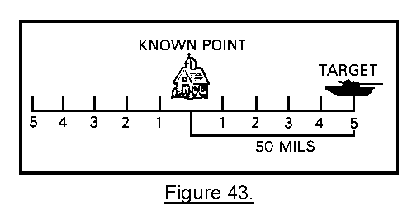
Sometimes the known point and the target may be so far apart that you cannot align the center of the horizontal scale with the known point and still measure the angular deviation to the target. When this happens move the horizontal scale to the left or right until both the known point and the target are covered by the scale. Measure the number of mils between the known point and the target. |  | 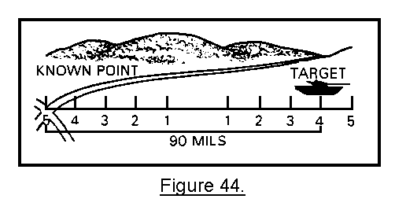

When the known point and the target are more than 100 mils apart--

• Move the horizontal scale to the left or right until the known point is located at one end of the scale. | 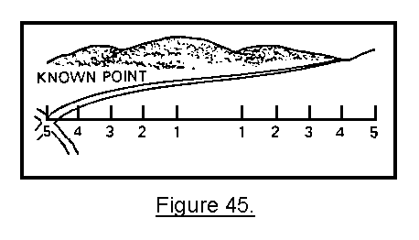

• Find an easily identifiable object near the target end of the scale (Figure 46). This object will become your reference point. | 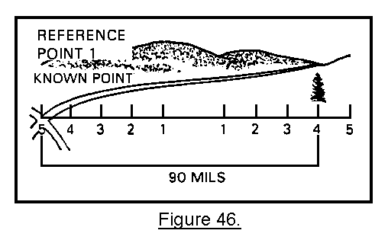
• Measure the number of mils from the known point to the reference point. Then move your binoculars until the reference point appears at the end of the scales where the known point was located. Then look for a new reference point on the other end of the scale (target end of scale) (Figure 47). | 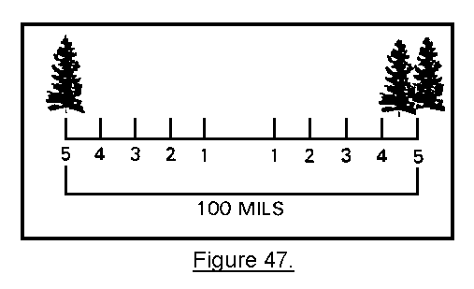
• Repeat the procedure until the target appears on the scale. Then measure the number of mils from the last reference point to the target (Figure 48). | 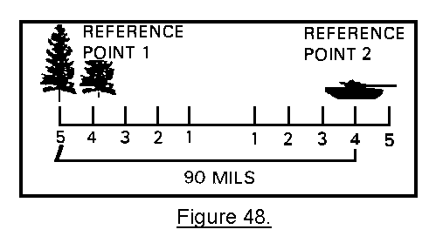
• Add the total number of mils between the known point and the target as shown in Figure 49.
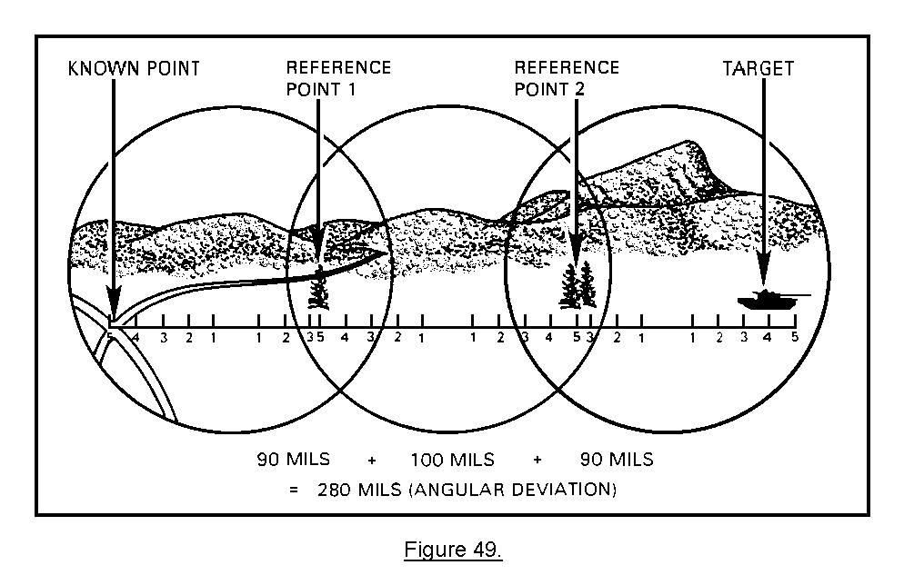
This method is called "leapfrogging."

NOTE: Do not use this method if the angular deviation is more than 600 mils.

PRACTICE EXERCISES:

SITUATION. Using the RALS rule, determine the direction to the targets shown in the illustrations below. Write your answers in the spaces provided.
32. Target direction _________ mils. | 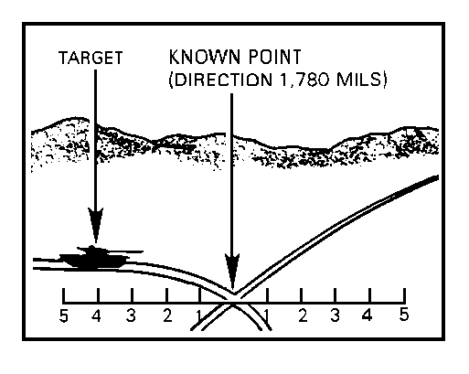
33. Target direction ____________ mils. | 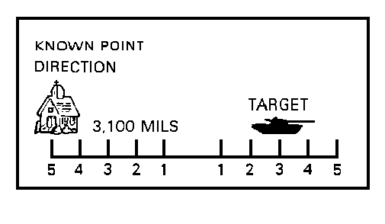
ANSWERS:

32. 1,740
33. 3,180

If you had any problems measuring angular deviations, review practice exercises 32 and 33. If not, continue.
31. LATERAL SHIFT. Lateral shift is how far, left or right, to the nearest 10 meters, the OT line is from the known point. Refer to Figure 50.  To determine the lateral shift, in meters, from the known point to the OT line, multiply the angular deviation by the distance to the known point divided by 1,000. This equation is called the mil relation formula. | 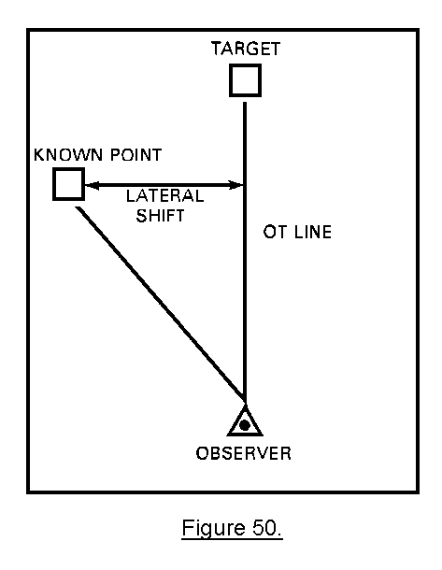
32. MIL RELATION FORMULA. Once you have established the distance to the known point, you will use the mil relation formula to convert the angular deviations, in mils, to a lateral shift, in meters.

mil relation formula:

W = R x m

W = lateral shift in meters.
R = observer to known point distance (rounded to nearest 100 meters) divided by 1,000.
m = angular deviation in mils (to the nearest 1 mil).

Follow this sample problem by using the mil relation formula to determine a lateral shift. Refer to Figure 51 and the step-by-step instructions below.

KNOWN: Direction to known point 0850 mils
Distance to known point 2,500 meters
Angular deviation right 60 mils
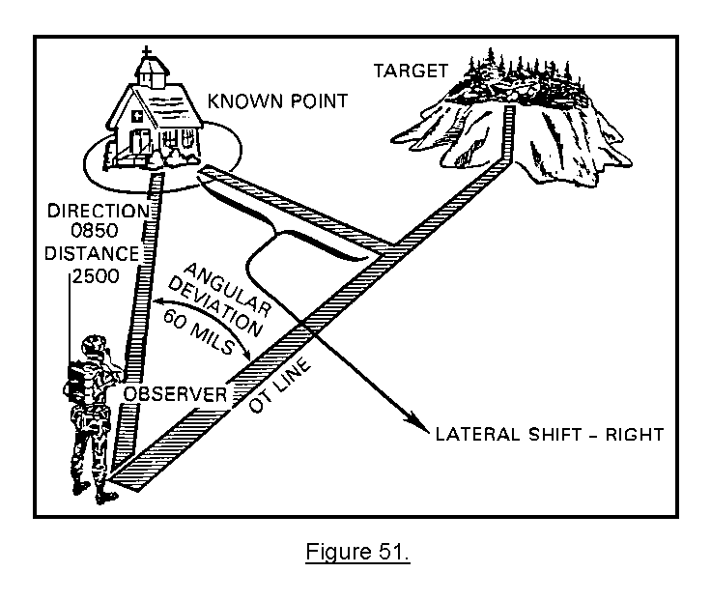
• Round the distance to the known point to the nearest 100 meters, and divide by 1,000.

2,500 rounded to the nearest 100 = 2,500

2,500 divided by 1,000 = 2.5

Value of R in mil relation formula = 2.5

• Multiply the R value by the m value. (m is angular deviation of 60 mils.)

2.5 x 60 = 150 meters. (R x m = W) 150 meters is the W value.

So, the lateral shift is RIGHT 150. Remember, lateral shift is expressed to the nearest 10 meters.

PRACTICE EXERCISES:

SITUATION. You have spotted two targets. Determine the lateral shift for each target using the information provided for each illustration below. Write in the spaces provided.

34. Known = Direction to known point 2,330 mils
Direction to known point 3,000 meters
Angular deviation left 110 mils

Lateral shift ___________________
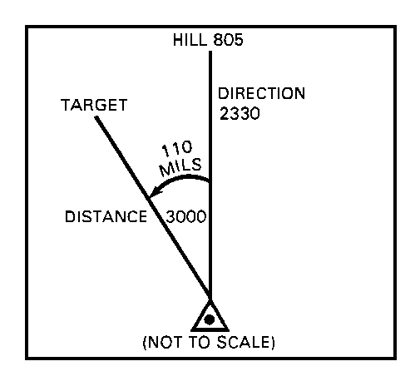
35. Known = Direction to known point 2,210 mils
Distance to known point 4,000 meters
Angular deviation right 220 mils

Lateral shift ___________________
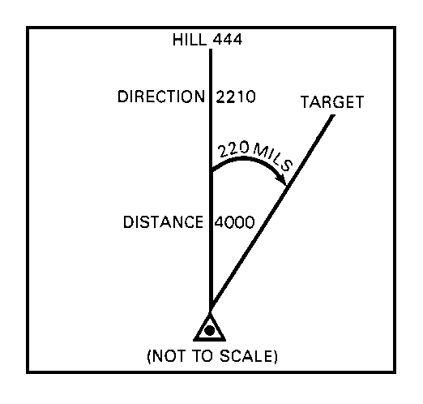
ANSWERS:

34. LEFT 330 (3.0 x 110)
35. RIGHT 880 (4.0 x 220)

If you had any problems with practice exercises 34 and 35, review them. If you had no problems, continue.

33. RANGE SHIFT. When the angular deviation is less than 600 mils, the shift in range is determined by comparing the distance from the observer to the known point with the distance from the observer to the target. Refer to Figure 52.
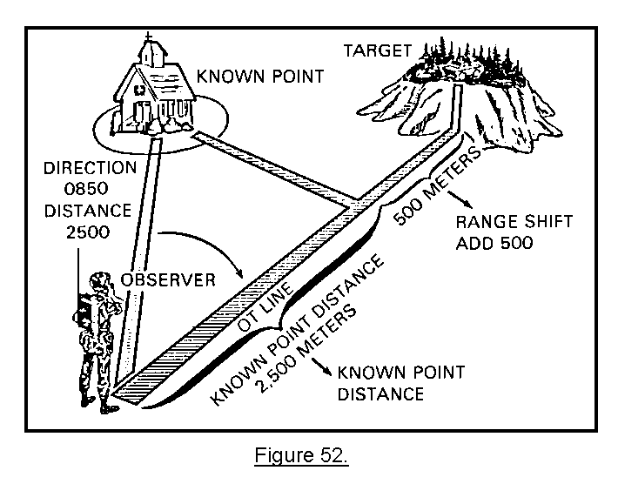
If the target is beyond the known point, the range shift will be add so many meters. If the target is short of the known point, the range shift will be drop so many meters. All that is required is to determine the difference between the distance to the known point and the distance to the target. The result is the range shift. Remember, range shifts are expressed to the nearest 100 meters.

PRACTICE EXERCISES:

SITUATION. You have spotted two targets and are using the known point method of target location. Determine the range shift for each target, as shown in each of the illustrations below.
36. Range shift ________________. | 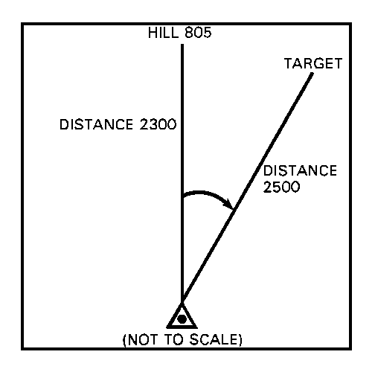

37. Range shift ______________. | 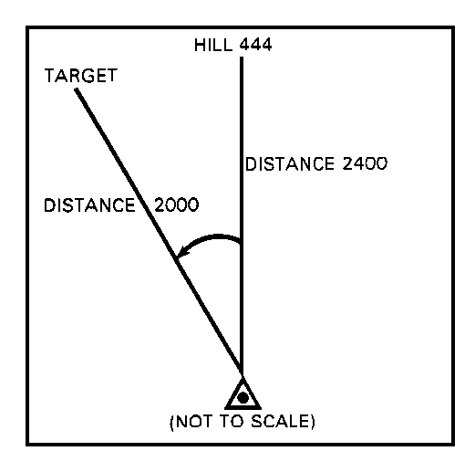
ANSWERS:

36. ADD 200
37. DROP 400

If you had problems with practice exercises 36 and 37, review them. If you did not have problems, continue.

34. VERTICAL SHIFT. The last element to be determined in locating a target by shift from a known point is the vertical shift. A vertical shift should be made when there is an obvious difference in the altitude of the target and the known point, not the observer and the known point. The shift normally is estimated; however, it may be computed if an angle-measuring instrument is available. Like the polar coordinate method of locating a target, the vertical shift is expressed to the nearest 5 meters. Vertical shift is determined by comparing the difference in altitude between the known point and the target. If the altitude of the target is greater than that of the known point, the direction of the vertical shift is up. If the altitude of the target is less than that of the known point, the direction of the shift is down.

NOTE: Only send vertical shift when the difference in altitude is greater than 30 meters.

PRACTICE EXERCISES:

38. T F A known point can be a target that has been fired on.

39. T F The supporting FDC does not have to know the location of the known point.

SITUATION. You have spotted two targets. Determine the angular deviation for each target as shown in each of the illustrations below. Write your answers in the spaces provided.
40. Angular deviation _____________ mils | 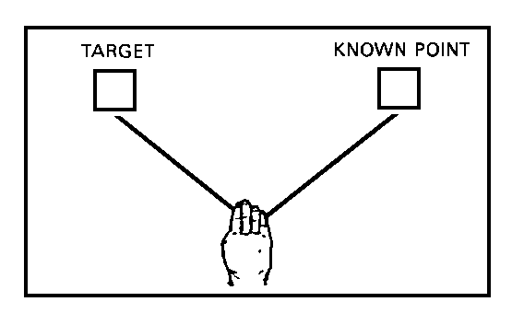
41. Angular deviation _______________ mils |  | 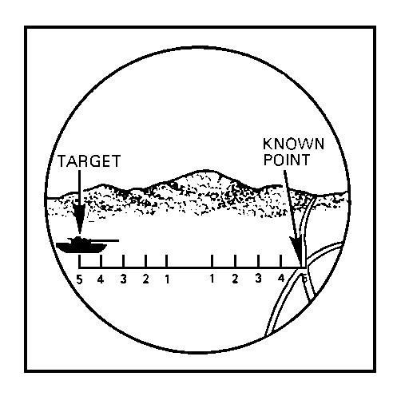
ANSWERS:

38. T
39. F
40. 125
41. 100

If you had any problems with practice exercises 38, 39, 40, and 41, review them. If you did not have problems, continue.

PRACTICE EXERCISES:

SITUATION. You have spotted two targets. Determine the target direction for each target as shown in each of the illustrations below. Write your answers in the spaces provided.
42. Target direction ___________ mils | 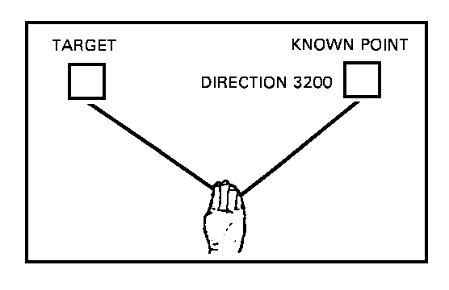
43. Target direction ________________ mils | 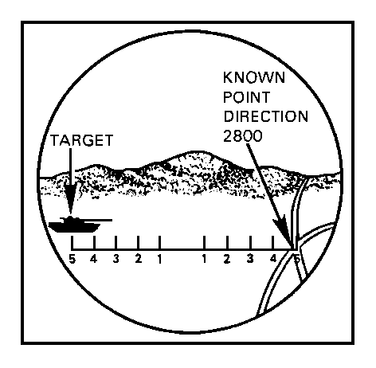
ANSWERS:

42. 3,080
43. 2,700

If you had problems with practice exercises 42 and 43, review them. If you did not have problems, continue.

PRACTICE EXERCISES:

SITUATION. You have spotted two targets. Determine the lateral shift for each target, as shown in each of the illustrations below. Write your answers in the spaces provided.
44. Lateral shift _________________ meters | 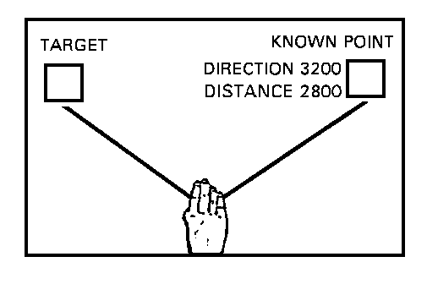
45. Lateral shift ___________________ meters | 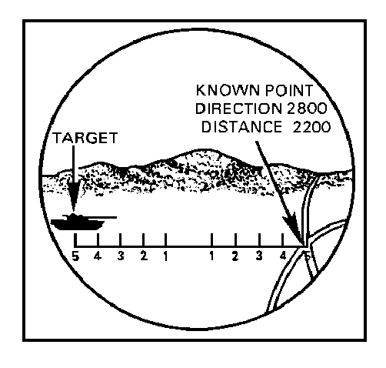
ANSWERS:

44. LEFT 350
45. LEFT 220

If you had problems with practice exercises 44 and 45, review them. If you did not have problems, continue.

PRACTICE EXERCISES:

SITUATION. You are locating a target by the shift from a known point method, and you have determined the information as shown in the illustration below. Write, in the space provided, the range change you determine for the target.
46. Range change __________________ | 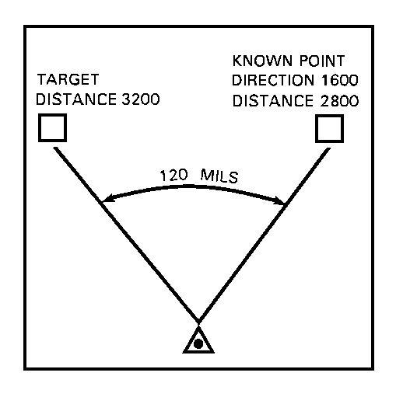
47. The two types of vertical shifts are __________ and ____________.

48. Vertical shifts are made in meters to the nearest _____________ meters.

ANSWERS:

46. ADD 400
47. UP, DOWN
48. 5

If you had problems with practice exercises 46, 47, and 48, review them. If you did not have problems, continue.

PRACTICE EXERCISE:

SITUATION. You have spotted a target. You do not have a map, but you have previously fired on a road junction near the target and already have the following data:

Direction to the road junction is 4,700 mils.
Distance to the road junction is 2,700 meters.
Angular deviation from the junction to the target is 80 mils (right).

You decide to locate the target using the shift from a known point method. You estimate the target to be 400 meters beyond the road junction and at about the same altitude. Write in the space provided the complete shift from a known point location you determine for this target.

49. Target location ___________________

ANSWER:

49. SHIFT ROAD JUNCTION
DIRECTION 4780
RIGHT 220
ADD 400

If you had problems with practice exercise 49, review it.

35. SUMMARY. Shift from a known point is the slowest of the three methods of target location. The five elements used for location of a target by the shift from a known point method are the known point for which to shift, the direction from the observer to the target, the lateral shift, the range shift, and the vertical shift.

